

**INDIVIDUAL ASSIGNMENT**

**TECHNOLOGY PARK MALAYSIA**

**CT071-3-3-DDAC**

**DESIGNING AND DEVELOPING APPLICATIONS ON THE CLOUD**

**UC3F1706SE**

**LECTURER : DR. KALAI ANAND RATNAM**

**HAND OUT DATE: WEEK 4**

**HAND IN DATE: WEEK 20**

**STUDENT NAME: ADEL MARATOVA**

**STUDENT TP NUMBER: TP032372**

# Acknowledgement

I would like to express a sincere gratitude to our lecturer, **Dr. Kalai Anand Ratnam**, for his hard work and dedication in explaining us module materials in a way that we could understand it thoroughly, apply and even get genuine interest in exploring the topics further. Throughout the whole duration of the module Dr. Kalai Anand Ratnam would always be in touch with all the students, finding the time to answer all the arisen questions and give us valuable notes and recommendations. Thanks for his guidance through completion of this coursework.

Table of Contents

Acknowledgement 2

1 Introduction 6

1.1 Project Background 6

1.2 Objectives 6

1.3 Scope 7

1.4 Requirement Specification 7

1.4.1 Functional requirements 7

1.4.2 Non-functional requirements 8

1.5 Summary of Major Functions 8

2 Project plan 11

3 Design 12

3.1 Cloud Architecture 12

3.1.1 Retry pattern 12

3.2 Implementation Architectural Diagrams 13

3.3 Design considerations 14

3.4 Modelling 15

3.4.1 Use Case Diagram 15

3.4.2 Use case description 16

3.4.3 Sequence diagram 39

3.4.4 Class diagram 55

4 Implementation 56

4.1 Publishing application to Azure 56

4.2 Publishing Database to Azure 61

4.3 Traffic Manager 63

4.4 Application Scaling with Justification 63

4.5 Investigate and Analyze Application 65

4.5.1 CPU Usage 65

4.5.2 Data Metrics 66

4.5.3 HTTP Requests 66

4.5.4 Total requests 67

4.5.5 Average Memory working set 67

4.6 Implementation and Discussions of Managed Databases (PaaS) 68

4.7 Screenshots of the Application 73

4.7.1 Home page 73

4.7.2 About us page 74

4.7.3 External shipment tracking page (for customers, without login) 74

4.7.4 Login page 75

4.7.5 Registration page 76

4.7.6 Logged in as Admin: Profile page 76

4.7.7 Confirmation message about account deletion 77

4.7.8 Admin profile edited successfully 77

4.7.9 Agents page 77

4.7.10 Add new agent page 78

4.7.11 Edit Agent info page 78

4.7.12 Agent profile edited successfully 78

4.7.13 Delete Agent profile 79

4.7.14 Countries page 79

4.7.15 Add new country 80

4.7.16 Edit cities page 80

4.7.17 Add new city (edit cities page) 81

4.7.18 Shipments page 81

4.7.19 Shipment methods page 82

4.7.20 Add new shipment page 82

4.7.21 Add New Shipment Method 83

4.7.22 Shipment Route Page 83

4.7.23 Add New Shipment Route Page 84

4.7.24 Edit shipment route page 84

4.7.25 Login as Agent: Profile page 85

4.7.26 Customers page 85

4.7.27 Add New Customer Page 86

4.7.28 Shipments page 86

4.7.29 Add New Shipment Page 87

4.7.30 Edit Shipment Page 87

4.7.31 Shipment History Page 88

4.7.32 Internal shipment tracking page 88

4.7.33 Login as Customer 89

4.7.34 Shipment Request Evaluation for Customer 89

4.7.35 Shipment request sent by customer 90

5 Test Plan and Testing Discussion 91

5.1 Test Plan 91

5.1.1 Unit testing 91

5.2 Performance Testing 96

6 Conclusion 99

7 References 99

# Introduction

## Project Background

Established in 1928 in Denmark, Maersk Line became the biggest container shipping company in the world nowadays with 374 offices spreaded over 116 countries. The company provides container transportation services for by both sea and by land, hiring 32,000 employees worldwide. The total cargo capacity of the all of the company’s vessels is evaluated at 2,6 million TEU (the twenty-foot equivalent) allowing to ship numerous containers worldwide.

Throughout the decades the company Maersk Line has been successfully developing and expanding its business worldwide and from the side it may seem that they found their best way to manage all the cargo, however recently as it was noted by Maersk, the volume of shipment has reached its full capacity.

In order to continue successfully handling the container shipment orders, it was decided to enhance Maersk Line Container Management System, by automatizing it, making it more efficient, reliable, less influenced by human error and less costly to maintain. The enhancement implies implementation of cloud powered solutions for storing all the data. Since the company is already having partnership with Microsoft, it was decided to move forward expanding the use of their products from desktop solutions to container management.

## Objectives

The Maersk CMS project has several objectives, which are as follows:

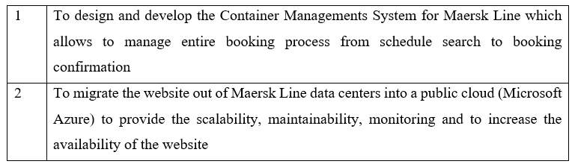

## Scope

The scope of the following project involves designing, developing and deploying the Container Management System into the Microsoft Azure public cloud platform. The proposed system will allow Maersk Line staff to manage bookings and all other processes from import, export and transhipment processing to gate operations, providing assurance and reliability through the Failover Management.

## Requirement Specification

The Maersk Line Container Management System should meet the following listed functional and non-functional requirements.

### Functional requirements

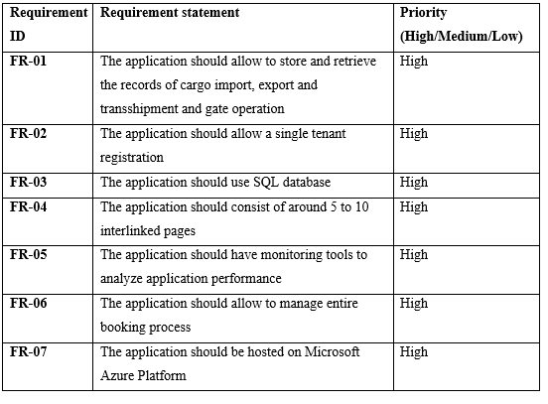

Figure 1. Functional requirements

### Non-functional requirements

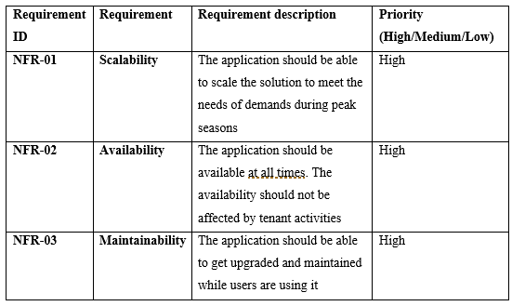

Figure 2. Non-functional requirements

## Summary of Major Functions

The Maersk Line Container Management System has following functions available to 3 types of users: Admin, Agent, Customer.

**Functions for Admin:**

1. ***Agents management***

* Create agent profile
* View agent profile
* Edit agent profile
* Delete agent profile

1. ***Location management***

* Add/edit countries
* Add/edit cities

1. ***Route management***

* Create routes between locations
* Edit routes between locations

1. ***Vessel management***

* Create vessel
* Edit vessel
* Delete vessel

1. ***Authentication***

* Login
* Logout

The registration for admin is happening at the backend for security reasons, therefore admin cannot register themselves.

**Functions for Agent:**

1. ***Customer management***

* Create customer profile
* View customer profile
* Edit customer profile
* Delete customer profile

1. ***Item registration***

* Create shipment

1. ***Book vessel***

* Book vessel for shipment

1. ***Confirmation***

* View customer shipping request
* Confirm/Reject customer shipping request

1. ***Shipment management***

* View current shipments
* Manage shipment movement
* Update shipment status
* Track shipment

**Functions for Customer:**

1. ***Shipment tracking***

* Externally track container using tracking number

1. ***Request container shipment***

* Create shipping request

# Project plan

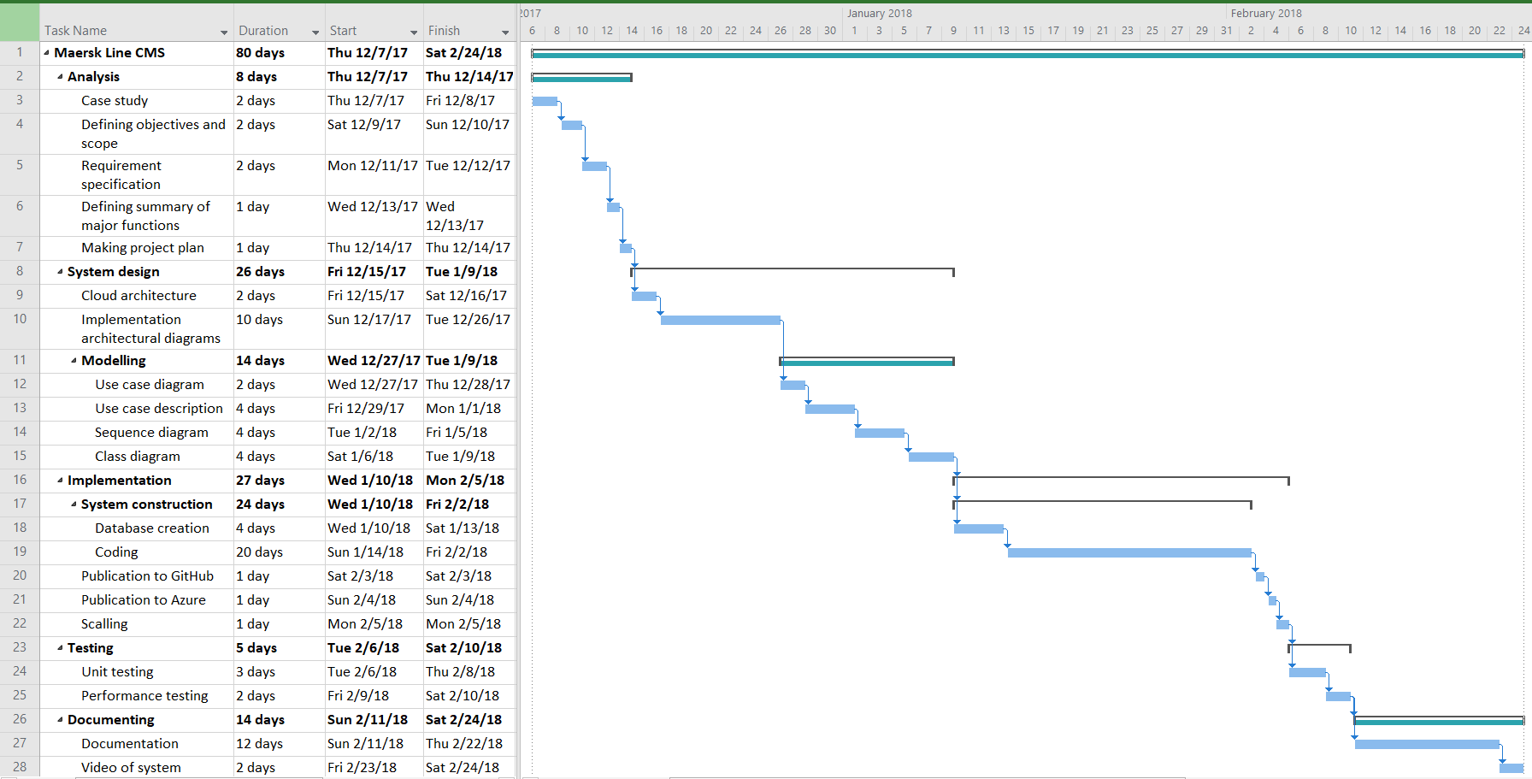

Figure 3. MaerskLine CMS Project Gantt Chart

# Design

## Cloud Architecture

### Retry pattern

The cloud - based applications quite often gets transient failures. Those failures mainly occur for 2 reasons. First is its dependence on the network connectivity, as in case the network got momentary interrupted - some of the services or resources may not be loaded or not fully loaded. Secondly, due to the timeouts that occurs when the service is busy. Both type of failures are usually self-correcting and just need a slight delay for repeating a triggering action, after what the problem is typically resolves (Docs.microsoft.com, 2018).

Enabling retry pattern allows to handle transient faults by retrying the failed operations. Overall it is improving the stability of the application.

This is handled using the following strategies:

* **Cancel**

In case the failure is indicated as most likely to be unsuccessful after the retry the Cancel strategy will be used, which implies the operation to be cancelled and the exception to be reported (Docs.microsoft.com, 2018).

* **Retry**

The retry strategy is applied when there is a non typical fault, so that it is most likely occurred due to such reason as packet being corrupted while being transmitted. The operation should be successful if the request will be sent again (Docs.microsoft.com, 2018).

* **Retry after delay**

Sometimes system might be busy or there is another reason like connectivity issue which causes operation failures. If this is detected, the application should wait for some time before sending another request (Docs.microsoft.com, 2018).

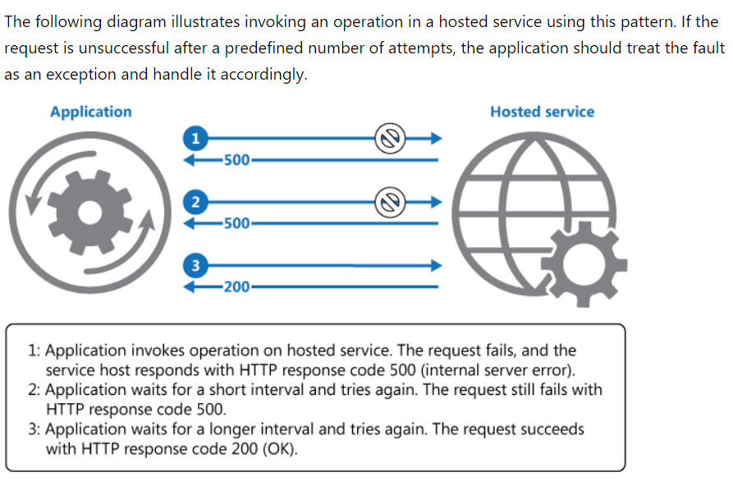

Figure 4. Operation invoking using Retry Pattern

## Implementation Architectural Diagrams



Figure 5. Architectural diagram

## Design considerations

There are certain aspects that were considered when designing a system, which are as listed below:

* The system should increase productivity
* The system should eradicate errors
* The system should have a quality design and content

## Modelling

### Use Case Diagram



Figure 6. Use Case Diagram

### Use case description

#### View list of agents

|  |  |
| --- | --- |
| Use Case ID | UC-01 |
| Use Case Name | View list of agents |
| Summary | This use case allows the admin user to view list of all the agents that are registered in the system |
| Dependency | - |
| Actor | Admin |
| Pre-condition | User must be logged in to the system as Admin |
| Main Sequence | 1. User clicks on “Agents” button on the side menu. 2. The system displays the list of the agents that are registered in the system. |
| Alternative Sequence | If there are no agents registered in the system:  2. The system returns empty list |
| Post-condition | The list of the agents that are registered in the system is displayed. |

#### Add new agent

|  |  |
| --- | --- |
| Use Case ID | UC-02 |
| Use Case Name | Add new agent |
| Summary | This use case allows the admin user to register new agent in the system |
| Dependency | View list of agents |
| Actor | Admin |
| Pre-condition | User must be logged in to the system as Admin |
| Main Sequence | 1. User clicks on “Agents” button on the side menu. 2. The system displays the list of the agents that are registered in the system. 3. The user clicks on “Add new agent” button. 4. The system displays the new agent registration form 5. The user enters new agent’s data and clicks “Save”. 6. The system creates new agent record in the database and displays updated list of registered agents including newly registered agent. |
| Alternative Sequence | **If there are no agents registered in the system:**  2. The system returns empty list.   1. The user clicks on “Add new agent” button. 2. The system displays the new agent registration form 3. The user enters new agent’s data and clicks “Save”. 4. The system creates new agent record in the database and displays updated list of registered agents including newly registered agent.   **If the user decided to cancel the creation of new agent:**  5. The user enters new agent’s data and clicks “Cancel”.  6. The system displays the list of registered agents without newly registered agent. |
| Post-condition | The new agent record in the database is created and updated list of registered agents including newly registered agent is displayed. |

#### View agent profile

|  |  |
| --- | --- |
| Use Case ID | UC-03 |
| Use Case Name | View agent profile |
| Summary | This use case allows the admin user to view agent profile |
| Dependency | View list of agents |
| Actor | Admin |
| Pre-condition | User must be logged in to the system as Admin |
| Main Sequence | 1. User clicks on “Agents” button on the side menu. 2. The system displays the list of the agents that are registered in the system. 3. The user clicks on “View” button next to agent’s name. 4. The system displays the agent’s profile. |
| Alternative Sequence | **-** |
| Post-condition | The agent’s profile is displayed |

#### Edit agent profile

|  |  |
| --- | --- |
| Use Case ID | UC-04 |
| Use Case Name | Edit agent profile |
| Summary | This use case allows the admin user to edit agent profile |
| Dependency | View list of agents |
| Actor | Admin |
| Pre-condition | User must be logged in to the system as Admin |
| Main Sequence | 1. User clicks on “Agents” button on the side menu. 2. The system displays the list of the agents that are registered in the system. 3. The user clicks on “View” button next to agent’s name. 4. The system displays the agent’s profile. 5. The user clicks “Edit” button. 6. The system displays the agent’s profile with all editable fields. 7. The user updates agent’s data and clicks “Save”. 8. The system updates new agent record in the database and displays agents profile with updated information. |
| Alternative Sequence | **If the user clicks “Cancel” after updating fields:**   1. The user updates agent’s data and clicks “Cancel”. 2. The system cancels changes to agent record in the fields and displays agents profile. |
| Post-condition | The agent record in the database is updated. |

#### Delete agent profile

|  |  |
| --- | --- |
| Use Case ID | UC-05 |
| Use Case Name | Delete agent profile |
| Summary | This use case allows the admin user to delete agent profile |
| Dependency | View list of agents |
| Actor | Admin |
| Pre-condition | User must be logged in to the system as Admin |
| Main Sequence | 1. User clicks on “Agents” button on the side menu. 2. The system displays the list of the agents that are registered in the system. 3. The user clicks on “View” button next to agent’s name. 4. The system displays the agent’s profile. 5. The user clicks “Delete” button. 6. The system displays the pop-up confirmation message: “Are you sure you want to delete? This changes cannot be undone.” 7. The user clicks “Ok”. 8. The system deletes agent record in the database and displays updated agents list. |
| Alternative Sequence | **If the user clicks “Cancel”:**   1. The user clicks “Cancel”. 2. The system displays agents profile. |
| Post-condition | The agent record in the database is deleted. |

#### View countries

|  |  |
| --- | --- |
| Use Case ID | UC-06 |
| Use Case Name | View countries |
| Summary | This use case allows the admin user to view list of all the countries that are registered in the system |
| Dependency | - |
| Actor | Admin |
| Pre-condition | User must be logged in to the system as Admin |
| Main Sequence | 1. User clicks on “Countries” button on the side menu. 2. The system displays the list of the agents that are registered in the system. |
| Alternative Sequence | **If there are no countries registered in the system:**  2. The system returns empty list |
| Post-condition | The list of the countries that are registered in the system is displayed. |

#### Add new country

|  |  |
| --- | --- |
| Use Case ID | UC-07 |
| Use Case Name | Add new country |
| Summary | This use case allows the admin user to register new country in the system |
| Dependency | View countries |
| Actor | Admin |
| Pre-condition | User must be logged in to the system as Admin |
| Main Sequence | 1. User clicks on “Countries” button on the side menu. 2. The system displays the list of the countries that are registered in the system. 3. The user clicks on “Add new country” button. 4. The system displays the new country registration form. 5. The user enters new country’s data and clicks “Save”. 6. The system creates new country record in the database and displays updated list of registered countries including newly registered country. |
| Alternative Sequence | **If there are no countries registered in the system:**  2. The system returns empty list.   1. The user clicks on “Add new country” button. 2. The system displays the new country registration form 3. The user enters new country’s data and clicks “Save”. 4. The system creates new country record in the database and displays updated list of registered country including newly registered country.   **If the user decided to cancel the creation of new country:**  5. The user enters new country’s data and clicks “Cancel”.  6. The system displays the list of registered countries without newly registered country. |
| Post-condition | The new country record in the database is created and updated list of registered country including newly registered country is displayed. |

#### Add new city

|  |  |
| --- | --- |
| Use Case ID | UC-08 |
| Use Case Name | Add new city |
| Summary | This use case allows the admin user to register new city of the existing country |
| Dependency | View countries |
| Actor | Admin |
| Pre-condition | User must be logged in to the system as Admin |
| Main Sequence | 1. User clicks on “Countries” button on the side menu. 2. The system displays the list of the countries that are registered in the system. 3. The user clicks on “View” button next to the country. 4. The system displays the country profile. 5. The user clicks on “Add new city” button. 6. The system shows new city registration form. 7. The user enters new city’s data and clicks “Save”. 8. The system creates new city record in the database. |
| Alternative Sequence | **If the user decided to cancel the creation of new city:**  5. The user enters new city’s data and clicks “Cancel”.  6. The system cancels the creation of new city and displays the country profile. |
| Post-condition | The new city record in the database is created. |

#### Edit cities

|  |  |
| --- | --- |
| Use Case ID | UC-09 |
| Use Case Name | Edit cities |
| Summary | This use case allows the admin user to edit city of the existing country |
| Dependency | View countries |
| Actor | Admin |
| Pre-condition | User must be logged in to the system as Admin |
| Main Sequence | 1. User clicks on “Countries” button on the side menu. 2. The system displays the list of the countries that are registered in the system. 3. The user clicks on “View” button next to the country. 4. The system displays the country profile. 5. The user clicks on “Edit” button next to the city. 6. The system shows city details form. 7. The user updates city’s data and clicks “Save”. 8. The system updates city record in the database. |
| Alternative Sequence | **If the user decided to cancel the update of new city:**  6. The user updates city’s data and clicks “Cancel”.  7. The system cancel the changes to new city and displays the country profile. |
| Post-condition | The city record in the database is updated. |

#### View routes

|  |  |
| --- | --- |
| Use Case ID | UC-10 |
| Use Case Name | View routes |
| Summary | This use case allows the admin user to view list of all the routes that are registered in the system |
| Dependency | - |
| Actor | Admin |
| Pre-condition | User must be logged in to the system as Admin |
| Main Sequence | 1. User clicks on “Routes” button on the side menu. 2. The system displays the list of the routes that are registered in the system. |
| Alternative Sequence | **If there are no routes registered in the system:**  2. The system returns empty list |
| Post-condition | The list of the routes that are registered in the system is displayed. |

#### Add new route

|  |  |
| --- | --- |
| Use Case ID | UC-11 |
| Use Case Name | Add new route |
| Summary | This use case allows the admin user to register new route in the system |
| Dependency | View routes |
| Actor | Admin |
| Pre-condition | User must be logged in to the system as Admin |
| Main Sequence | 1. User clicks on “Routes” button on the side menu. 2. The system displays the list of the routes that are registered in the system. 3. The user clicks on “Add new route” button. 4. The system displays the new route form. 5. The user enters new route’s data and clicks “Save”. 6. The system creates new route record in the database and displays updated list of routes including newly registered route. |
| Alternative Sequence | **If there are no routes registered in the system:**  2. The system returns empty list.   1. The user clicks on “Add new route” button. 2. The system displays the new route form. 3. The user enters new route’s data and clicks “Save”. 4. The system creates new route record in the database and displays updated list of routes including newly registered route.   **If the user decided to cancel the creation of new country:**  5. The user enters new route’s data and clicks “Cancel”.  6. The system displays the list of registered routes without newly registered route. |
| Post-condition | The new route record in the database is created and updated list of registered country including newly registered route is displayed. |

#### Edit route

|  |  |
| --- | --- |
| Use Case ID | UC-12 |
| Use Case Name | Edit route |
| Summary | This use case allows the admin user to edit route |
| Dependency | View routes |
| Actor | Admin |
| Pre-condition | User must be logged in to the system as Admin |
| Main Sequence | 1. User clicks on “Routes” button on the side menu. 2. The system displays the list of the routes that are registered in the system. 3. The user clicks on “View” button next to route’s name. 4. The system displays the route. 5. The user clicks “Edit” button. 6. The system displays the route page with all editable fields. 7. The user updates route’s data and clicks “Save”. 8. The system updates new route record in the database and displays route profile with updated information. |
| Alternative Sequence | **If the user clicks “Cancel” after updating fields:**   1. The user updates agent’s data and clicks “Cancel”. 2. The system cancels changes to route record in the fields. |
| Post-condition | The route record in the database is updated. |

#### View vessels

|  |  |
| --- | --- |
| Use Case ID | UC-13 |
| Use Case Name | View vessels |
| Summary | This use case allows the admin user to view list of all the vessels that are registered in the system |
| Dependency | - |
| Actor | Admin |
| Pre-condition | User must be logged in to the system as Admin |
| Main Sequence | 1. User clicks on “Vessels” button on the side menu. 2. The system displays the list of the vessels that are registered in the system. |
| Alternative Sequence | **If there are no vessels registered in the system:**  2. The system returns empty list |
| Post-condition | The list of the vessels that are registered in the system is displayed. |

#### Add new vessel

|  |  |
| --- | --- |
| Use Case ID | UC-14 |
| Use Case Name | Add new vessel |
| Summary | This use case allows the admin user to register new vessel in the system |
| Dependency | View vessels |
| Actor | Admin |
| Pre-condition | User must be logged in to the system as Admin |
| Main Sequence | 1. User clicks on “Vessels” button on the side menu. 2. The system displays the list of the vessels that are registered in the system. 3. The user clicks on “Add new vessel” button. 4. The system displays the new vessel form. 5. The user enters new vessel’s data and clicks “Save”. 6. The system creates new vessel record in the database and displays updated list of vessels including newly registered vessel. |
| Alternative Sequence | **If there are no vessels registered in the system:**  2. The system returns empty list.   1. The user clicks on “Add new vessel” button. 2. The system displays the new vessel form. 3. The user enters new vessel’s data and clicks “Save”. 4. The system creates new vessel record in the database and displays updated list of vessels including newly registered vessel.   **If the user decided to cancel the creation of new vessel:**  5. The user enters new vessel’s data and clicks “Cancel”.  6. The system displays the list of registered vessel without newly registered vessel. |
| Post-condition | The new vessel record in the database is created and updated list of registered vessela including newly registered vessel is displayed. |

#### Edit vessel

|  |  |
| --- | --- |
| Use Case ID | UC-15 |
| Use Case Name | Edit vessel |
| Summary | This use case allows the admin user to register update vessel details in the system |
| Dependency | View vessels |
| Actor | Admin |
| Pre-condition | User must be logged in to the system as Admin |
| Main Sequence | 1. User clicks on “Vessels” button on the side menu. 2. The system displays the list of the vessels that are registered in the system. 3. The user clicks on “Edit vessel” button. 4. The system displays the editable vessel form. 5. The user updates vessel’s data and clicks “Save”. 6. The system updates new vessel record in the database. |
| Alternative Sequence | **If the user decided to cancel the creation of new vessel:**  5. The user updates vessel’s data and clicks “Cancel”.  6. The system displays cancels the changes made to vessel’s details. |
| Post-condition | The vessel record in the database is updated. |

#### Delete vessel

|  |  |
| --- | --- |
| Use Case ID | UC-16 |
| Use Case Name | Delete vessel |
| Summary | This use case allows the admin user to delete vessel in the system |
| Dependency | View vessels |
| Actor | Admin |
| Pre-condition | User must be logged in to the system as Admin |
| Main Sequence | 1. User clicks on “Vessels” button on the side menu. 2. The system displays the list of the vessels that are registered in the system. 3. The user clicks on “View vessel” button. 4. The system displays the vessel information page. 5. The user clicks “Delete”. 6. The system pops-up confirmation message. 7. The user clicks “Ok” button. 8. The system deletes vessel record from database and displays update vessels list. |
| Alternative Sequence | **-** |
| Post-condition | The vessel record in the database is deleted. |

#### Login

|  |  |
| --- | --- |
| Use Case ID | UC-17 |
| Use Case Name | Login |
| Summary | This use case allows the admin and agent users to login |
| Dependency | - |
| Actor | Admin or Agent |
| Pre-condition | User must be registered in the system |
| Main Sequence | 1. User clicks on “Login” button. 2. The system displays login page interface. 3. The user enters username and password and clicks “Login” button. 4. The system verifies the user credentials. 5. The system displays main page. |
| Alternative Sequence | **If the credentials are incorrect:**   1. The system displays error message 2. The user clicks “Ok”. 3. The system displays login page interface. 4. The user enters username and password and clicks “Login” button. 5. The system verifies the user credentials. 6. The system displays main page. |
| Post-condition | The user is signed in and sees the main page depending on the role. |

#### Logout

|  |  |
| --- | --- |
| Use Case ID | UC-18 |
| Use Case Name | Logout |
| Summary | This use case allows the admin and agent users to logout |
| Dependency | Login |
| Actor | Admin or Agent |
| Pre-condition | User must be logged in to the system |
| Main Sequence | 1. User clicks on “Logout” button on the side menu. 2. The system displays login page interface. |
| Alternative Sequence | - |
| Post-condition | The user is signed out. |

#### View list of customers

|  |  |
| --- | --- |
| Use Case ID | UC-19 |
| Use Case Name | View list of customers |
| Summary | This use case allows the Agent user to view list of all the customers that are registered in the system |
| Dependency | - |
| Actor | Agent |
| Pre-condition | User must be logged in to the system as Agent |
| Main Sequence | 1. User clicks on “Customers” button on the side menu. 2. The system displays the list of the customers that are registered in the system. |
| Alternative Sequence | **If there are no customers registered in the system:**  2. The system returns empty list |
| Post-condition | The list of the customers that are registered in the system is displayed. |

#### Add new customer

|  |  |
| --- | --- |
| Use Case ID | UC-20 |
| Use Case Name | Add new customer |
| Summary | This use case allows the Agent user to register new customer in the system |
| Dependency | View list of customers |
| Actor | Agent |
| Pre-condition | User must be logged in to the system as Agent |
| Main Sequence | 1. User clicks on “Customers” button on the side menu. 2. The system displays the list of the customers that are registered in the system. 3. The user clicks on “Add new customer” button. 4. The system displays the new customer registration form. 5. The user enters new customer’s data and clicks “Save”. 6. The system creates new customer record in the database and displays updated list of vessels including newly registered vessel. |
| Alternative Sequence | **If the user decided to cancel the creation of new customer:**  5. The user enters new customer’s data and clicks “Cancel”.  6. The system displays the list of registered vessel without newly registered customer. |
| Post-condition | The new customer record in the database is created |

#### View customer profile

|  |  |
| --- | --- |
| Use Case ID | UC-21 |
| Use Case Name | View customer profile |
| Summary | This use case allows the Agent user to view profile the customer that are registered in the system |
| Dependency | - |
| Actor | Agent |
| Pre-condition | User must be logged in to the system as Agent |
| Main Sequence | 1. User clicks on “Customers” button on the side menu. 2. The system displays the list of the customers that are registered in the system. 3. The user clicks “View” button 4. The system displays the customer’s profile |
| Alternative Sequence | **-** |
| Post-condition | The profile of the customer is displayed. |

#### Edit customer profile

|  |  |
| --- | --- |
| Use Case ID | UC-22 |
| Use Case Name | Edit customer profile |
| Summary | This use case allows the Agent user to edit profile of the customer |
| Dependency | - |
| Actor | Agent |
| Pre-condition | User must be logged in to the system as Agent |
| Main Sequence | 1. User clicks on “Customers” button on the side menu. 2. The system displays the list of the customers that are registered in the system. 3. The user clicks “View” button. 4. The system displays the customer’s profile. 5. The user clicks” Edit”. 6. The user makes all the fields with customer details editable. 7. The user makes changes and clicks “Save” 8. The systems updates customer record in the database. |
| Alternative Sequence | **If the user decided to cancel the changes to new customer records:**  5. The user changes customer’s data and clicks “Cancel”.  6. The system cancels changes made to the fields. |
| Post-condition | The profile of the customer is displayed. |

#### Delete customer profile

|  |  |
| --- | --- |
| Use Case ID | UC-23 |
| Use Case Name | Delete customer profile |
| Summary | This use case allows the admin user to delete customer profile in the databases |
| Dependency | View customers |
| Actor | Agent |
| Pre-condition | User must be logged in to the system as Agent |
| Main Sequence | 1. User clicks on “Customers” button on the side menu. 2. The system displays the list of the customers that are registered in the system. 3. The user clicks “View” button. 4. The system displays the customer’s profile. 5. The user clicks “Delete”. 6. The system pops-up confirmation message. 7. The user clicks “Ok” button. 8. The system deletes customer record from database and displays update customers list. |
| Alternative Sequence | **-** |
| Post-condition | The customer record in the database is deleted. |

#### View shipments

|  |  |
| --- | --- |
| Use Case ID | UC-24 |
| Use Case Name | View shipments |
| Summary | This use case allows the Agent user to view list of all the shipments that are registered in the system |
| Dependency | - |
| Actor | Agent |
| Pre-condition | User must be logged in to the system as Agent |
| Main Sequence | 1. User clicks on “Shipments” button on the side menu. 2. The system displays the list of the shipments that are registered in the system. |
| Alternative Sequence | **If there are no shipments registered in the system:**  2. The system returns empty list |
| Post-condition | The list of the shipments that are registered in the system is displayed. |

#### Add new shipment

|  |  |
| --- | --- |
| Use Case ID | UC-25 |
| Use Case Name | Add new shipment |
| Summary | This use case allows the Agent user to register new shipment in the system |
| Dependency | View list of shipments |
| Actor | Agent |
| Pre-condition | User must be logged in to the system as Agent |
| Main Sequence | 1. User clicks on “Shipments” button on the side menu. 2. The system displays the list of the shipments that are registered in the system. 3. The user clicks on “Add new shipment” button. 4. The system displays the new shipment registration form. 5. The user enters new shipment data and clicks “Save”. 6. The system creates new shipment record in the database and displays updated list of shipments including newly registered shipment. |
| Alternative Sequence | **If the user decided to cancel the creation of new shipmen**t**:**  5. The user enters new shipment data and clicks “Cancel”.  6. The system displays the list of registered shipments without newly registered shipment. |
| Post-condition | The new shipment record in the database is created |

#### Update shipment status

|  |  |
| --- | --- |
| Use Case ID | UC-26 |
| Use Case Name | Update shipment status |
| Summary | This use case allows the Agent user to update shipment status |
| Dependency | View list of shipments |
| Actor | Agent |
| Pre-condition | User must be logged in to the system as Agent |
| Main Sequence | 1. User clicks on “Shipments” button on the side menu. 2. The system displays the list of the shipments that are registered in the system. 3. The user clicks on “View” button. 4. The system displays the shipment profile. 5. The user clicks “Dispatch”. 6. The system update shipment status record in the database |
| Alternative Sequence | **If the shipments status == dispatched:**   1. The user clicks “Receive”. 2. The system update shipment status record in the database |
| Post-condition | The new shipment status record in the database is updated. |

#### Track shipment

|  |  |
| --- | --- |
| Use Case ID | UC-27 |
| Use Case Name | Track shipment |
| Summary | This use case allows the Agent user to track the shipment by ShimpentID. |
| Dependency | - |
| Actor | Agent |
| Pre-condition | User must be logged in to the system as Agent |
| Main Sequence | 1. User clicks on “Shipment tracking” button on the side menu. 2. The system displays the shipment tracking screen. 3. The user enters shipment ID number and clicks “View tracking”. 4. The system displays the tracking history of shipment. |
| Alternative Sequence | **If there are no shipments registered in the system:**  2. The system returns “No shipment found” message |
| Post-condition | The tracking history of shipment is displayed. |

#### View status

|  |  |
| --- | --- |
| Use Case ID | UC-28 |
| Use Case Name | View status |
| Summary | This use case allows the Agent user to view shipment status. |
| Dependency | - |
| Actor | Agent |
| Pre-condition | User must be logged in to the system as Agent |
| Main Sequence | 1. User clicks on “Shipment tracking” button on the side menu. 2. The system displays the shipment tracking screen. 3. The user enters shipment ID number and clicks “View tracking”. 4. The system displays the tracking history of shipment including the shipment status. |
| Alternative Sequence | **If there are no shipments registered in the system:**  2. The system returns “No shipment found” message |
| Post-condition | The status of shipment is displayed. |

#### View customer shipping request

|  |  |
| --- | --- |
| Use Case ID | UC-29 |
| Use Case Name | View customer shipping request |
| Summary | This use case allows the Agent user to view shipment status. |
| Dependency | - |
| Actor | Agent |
| Pre-condition | User must be logged in to the system as Agent |
| Main Sequence | 1. User clicks on “Shipments” button on the side menu. 2. The system displays the list of the shipments that are registered in the system. 3. The user clicks on shipment where status is pending 4. The system displays customer shipping request |
| Alternative Sequence | **If there are no shipments registered in the system:**  2. The system returns “No shipment found” message |
| Post-condition | The customer shipping request is displayed. |

#### Confirm shipping request

|  |  |
| --- | --- |
| Use Case ID | UC-30 |
| Use Case Name | Confirm shipping request |
| Summary | This use case allows the Agent user to confirm shipment request |
| Dependency | - |
| Actor | Agent |
| Pre-condition | User must be logged in to the system as Agent |
| Main Sequence | 1. User clicks on “Shipments” button on the side menu. 2. The system displays the list of the shipments that are registered in the system. 3. The user clicks on shipment where status is pending 4. The system displays customer shipping request 5. The user clicks on “Approve” button |
| Alternative Sequence | **If there are no shipments registered in the system:**  2. The system returns “No shipment found” message |
| Post-condition | The customer shipping request is approved. |

#### Reject shipping request

|  |  |
| --- | --- |
| Use Case ID | UC-31 |
| Use Case Name | Reject shipping request |
| Summary | This use case allows the Agent user to confirm shipment request |
| Dependency | - |
| Actor | Agent |
| Pre-condition | User must be logged in to the system as Agent |
| Main Sequence | 1. User clicks on “Shipments” button on the side menu. 2. The system displays the list of the shipments that are registered in the system. 3. The user clicks on shipment where status is pending 4. The system displays customer shipping request 5. The user clicks on “Reject” button |
| Alternative Sequence | **If there are no shipments registered in the system:**  2. The system returns “No shipment found” message |
| Post-condition | The customer shipping request is rejected. |

### Sequence diagram

#### Registration



Figure 7. Sequence Diagram: Registration

#### Login



Figure 8. Sequence Diagram:Login

#### View profile



Figure 9. Sequence Diagram: View Profile

#### Modify profile



Figure 10. Sequence Diagram:Modify Profile

#### Delete profile



Figure 11. Sequence Diagram: Delete Profile

#### View countries



Figure 12. Sequence Diagram: View Countries

#### Add new country



Figure 13. Sequence Diagram: Add New Country

#### View cities



Figure 14. Sequence Diagram: View Cities

#### Add new city



Figure 15. Sequence Diagram: Add new city

#### Edit city



Figure 16. Sequence Diagram: Edit City

#### View current shipments



Figure 17. Sequence Diagram: View Current Shipments

#### Add new shipment



Figure 18. Sequence Diagram: Add New Shipment

#### Edit shipment



Figure 19. Sequence Diagram: Edit Shipment

#### Manage shipment movement



Figure 20. Sequence Diagram: Manage Shipment Movement

#### Update shipment status (new, dispatched, received)



Figure 21. Sequence Diagram: Update Shipment Status

#### Track shipment



Figure 22. Sequence Diagram: Track Shipment

#### Logout



Figure 23. Sequence Diagram: Logout

### Class diagram

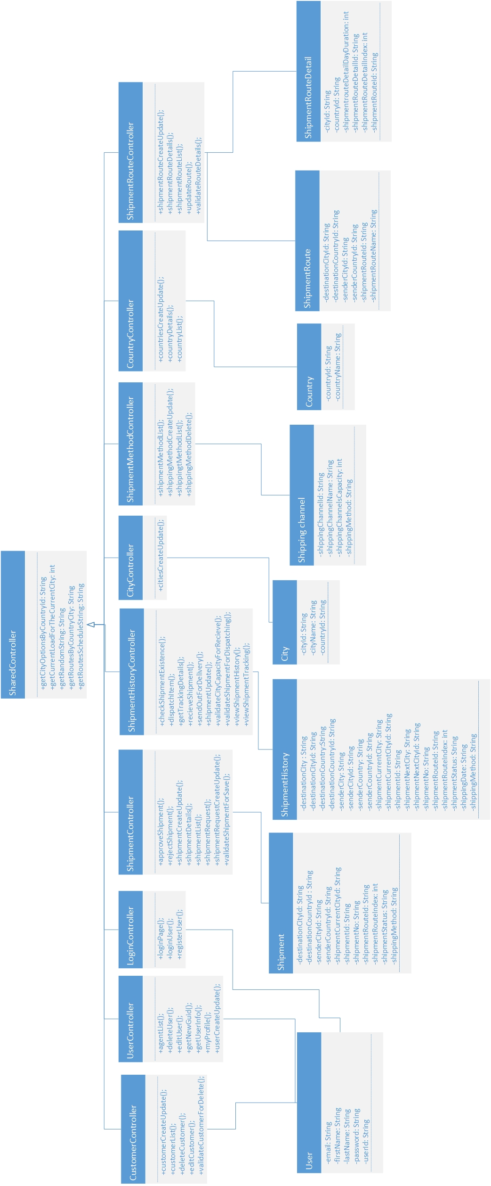

Figure 24. Class Diagram

# Implementation

## Publishing application to Azure

Once the application was designed and developed, the developer need publish it to Microsoft Azure.

In order to publish application to Azure the GitHub deployment will be used. The project will firstly be pushed to the specially created GitHub repository named “Maersk_cms”. And from the GitHub it will be deployed to Azure platform using deployment options of Azure.

The reason behind using GitHub as a deployment method is that it allows to easily control the versions of the code and in case of the errors, it allows to easily revert the code back to any of the previous versions. Furthermore, using GitHub allows to spend less time and effort uploading files to the cloud as it is done automatically instead of having to use FTP. Additionally, it is very convenient to make changes to application source code in the future, as once the changes made on the local machine are pushed to the GitHub repository, the changes are automatically applied to the deployed app.

1. ***Push source code to GitHub***

To push the project files to the repository on GitHub, the developer opened Git Bash, navigated to ContainerManagementSystem folder and performed following set of commands:

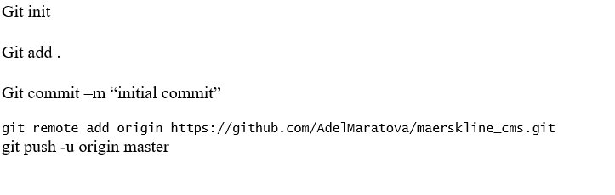

Figure 25. Set of Commands for publishing project to GitHub

This allowed to initialize git repository in the directory, add all of the files, commit the changes with the “initial commit” message, add repository and push the files.

Below is the GitHub repository with the Maersk Container Management System project files after being published to GitHub.

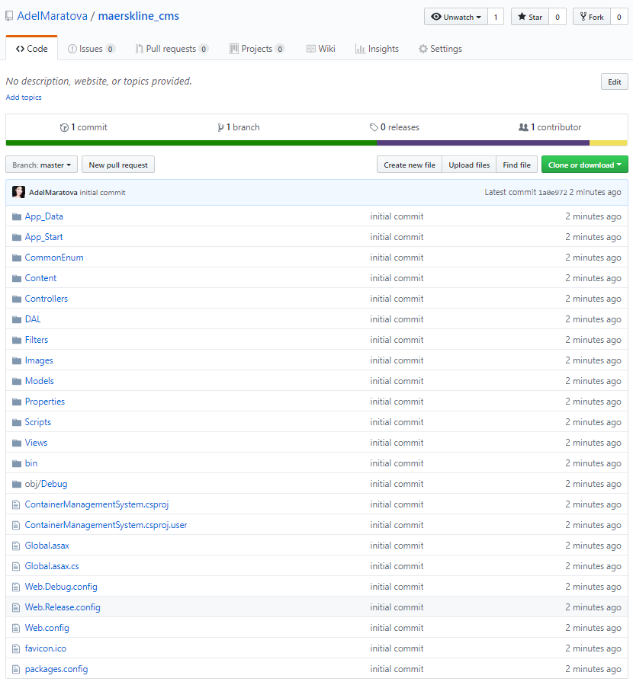

Figure 26. GitHub Repository

1. ***Create resource group***

The resource group is created under the maersk_cms name with the resource group location being Southeast Asia.

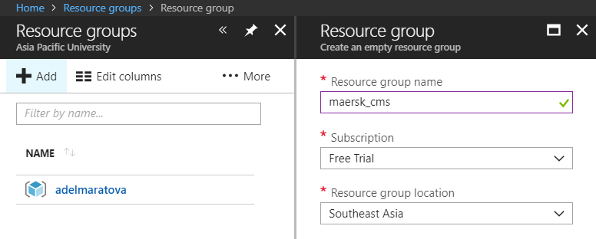

Figure 27. Resource Group Creation

1. ***Create application + SQL***

After the resource group was created the developer creates the application, with the SQL being included as there is a database in the system.

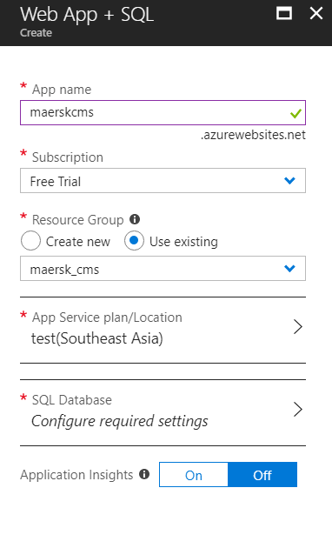

Figure 28. Creating new application

In order to create a database, the developer clicks on SQL Database and enters new database details as depicted on the diagram below.

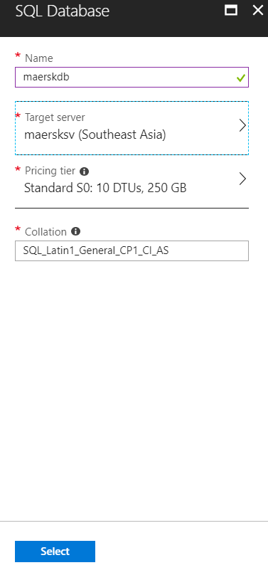

Figure 29. Creating New SQL Database

1. ***Deploy from GitHub***

The developers opens the deployment option choosing source as GitHub and entering

project details.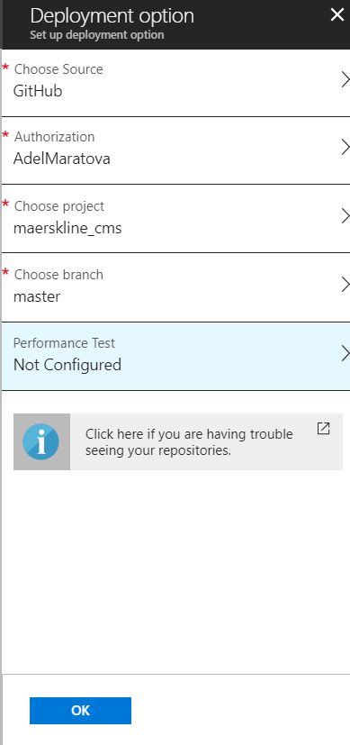

Figure 30.GitHub deployment

Upon clicking “OK” the Microsoft Azure deploys the project from repository.

## Publishing Database to Azure

Although the application is already available online, the user still cannot see anything more that static pages, like Landing Page or About Us page. This is because the project is not connected to database.

There was a database already created in the previous step. The developer needs to firstly configure its Firewall settings. This allows to register the IPs of devices the will be allowed to make changes to the database.

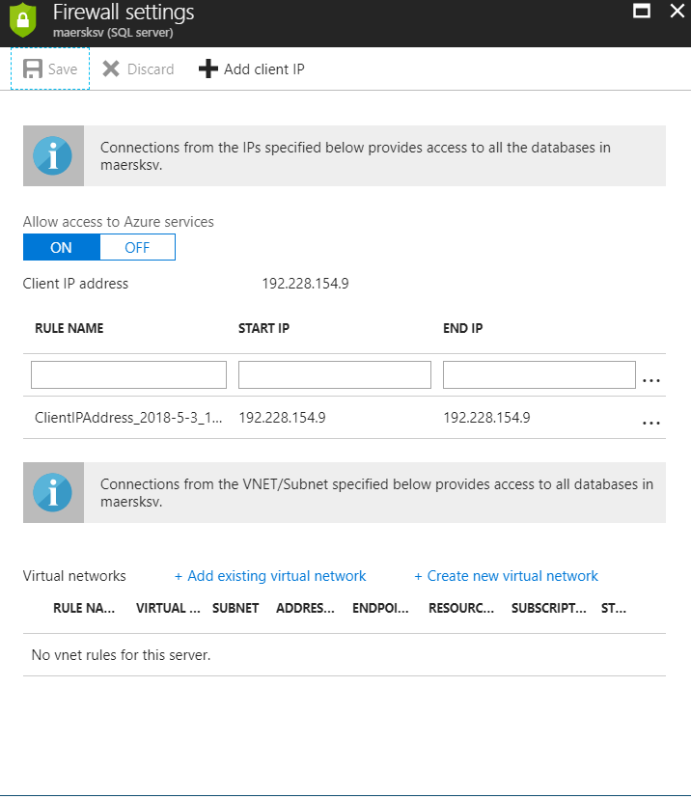

Figure 31. Firewall Settings

Then the developer connects to the Azure database from SQL Server Management Studio.

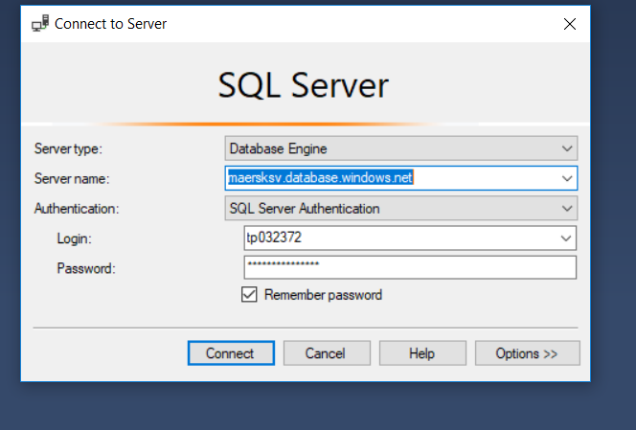

Figure 32. Connecting to Server

Once the connection is established, the developer right clicks on database title, choosing “Tasks” and then “Deploy to Microsoft Azure SQL Database”.

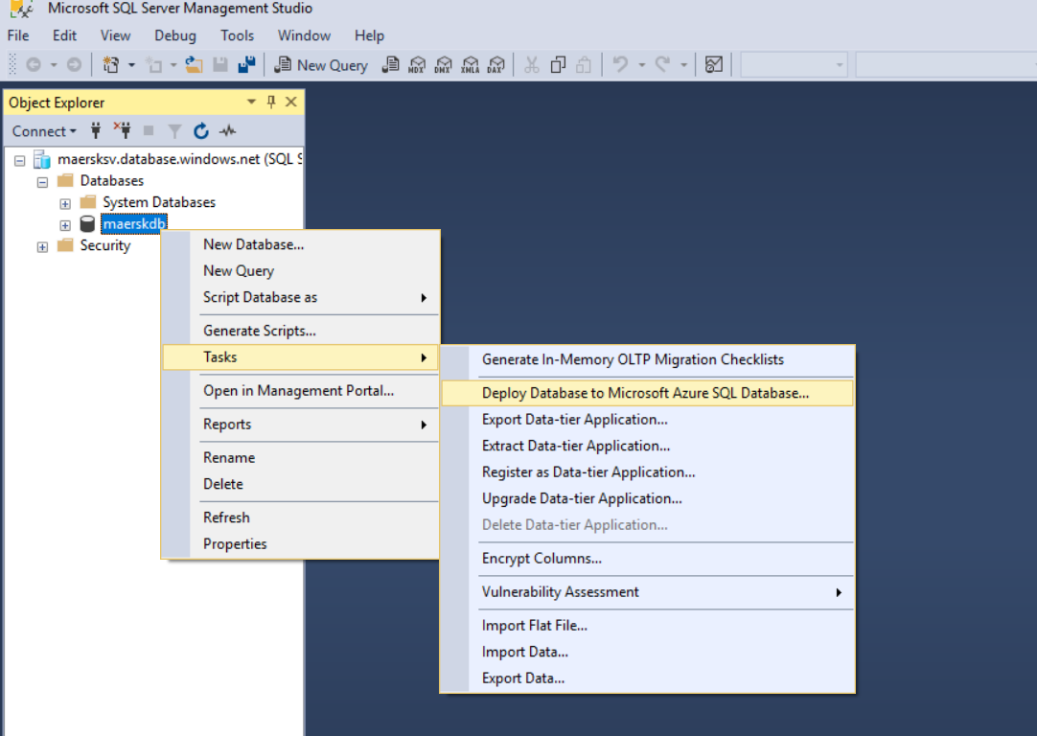

Figure 33. Database deployment

## Traffic Manager

The key requirements of the system were to be able to handle orders during the peak seasons as well as having a Failover Management. The Azure provides the tool for that which is called Traffic Manager. The traffic Manager allows to increase availability of the providing automatic Failover, when one of the endpoints of the system are down. Besides it allows to improve performance by reducing the server loads.

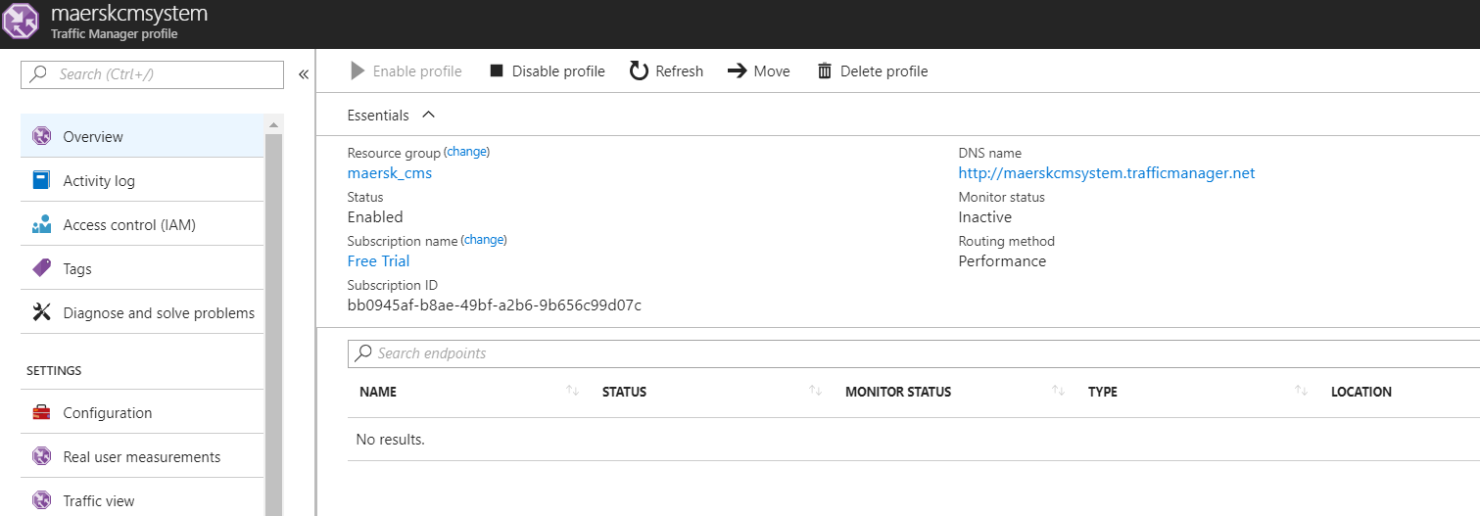

Figure 34. Traffic Manager

Depending on the location of the user who requests the CMS Maersk page, the traffic manager will redirect the user to most suitable endpoint based on profile settings, be performance, weighted, priority or geographic.

## Application Scaling with Justification

The Azure allows to scale the resources for the project. The Maersk Line Container Management System was initially deployed at S1 Standard Tier. After the performance test was conducted using light load (assuming the minimum amount of users) and heavy load (assuming the minimum amount of users) it was decided to change to S2 Standard Tier (please refer to Performance Testing section). Using S2 Standard Tier will allow to improve the performance of the application as it provides more RAM (3.5 GB RAM compared to 1.75 GB RAM in S1 StandaSrd tier) and has a better processing power in comparison with S1 Standard tier (2 Core versus S1 tier’s 2 Core).

|  |
| --- |
|  |
|  |
|  |

Figure 35.Tiers list

The following features comes with all of the tiers as shown below.

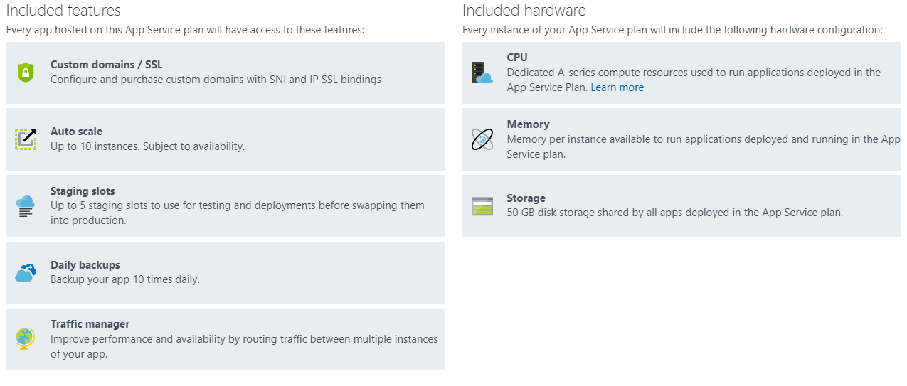

Figure 36. Features included in all tiers

Although the price of the S2 tier is 2 times more expensive that S1 tier, the benefits of the system performance and increased reliability totally worth that.

All of the standard plans have the auto scale option. The auto scale option allows to balance the load by spreading it evenly between few created instances of the application. The minimum and maximum number of instances are defined in rules, that are created for the auto scale.

Below there is an auto scale for the Maersk Line Container Management System. The rule for the system auto scale allows to create up to 3 instances during peak times, when the processor uses more than 70 % of the power.

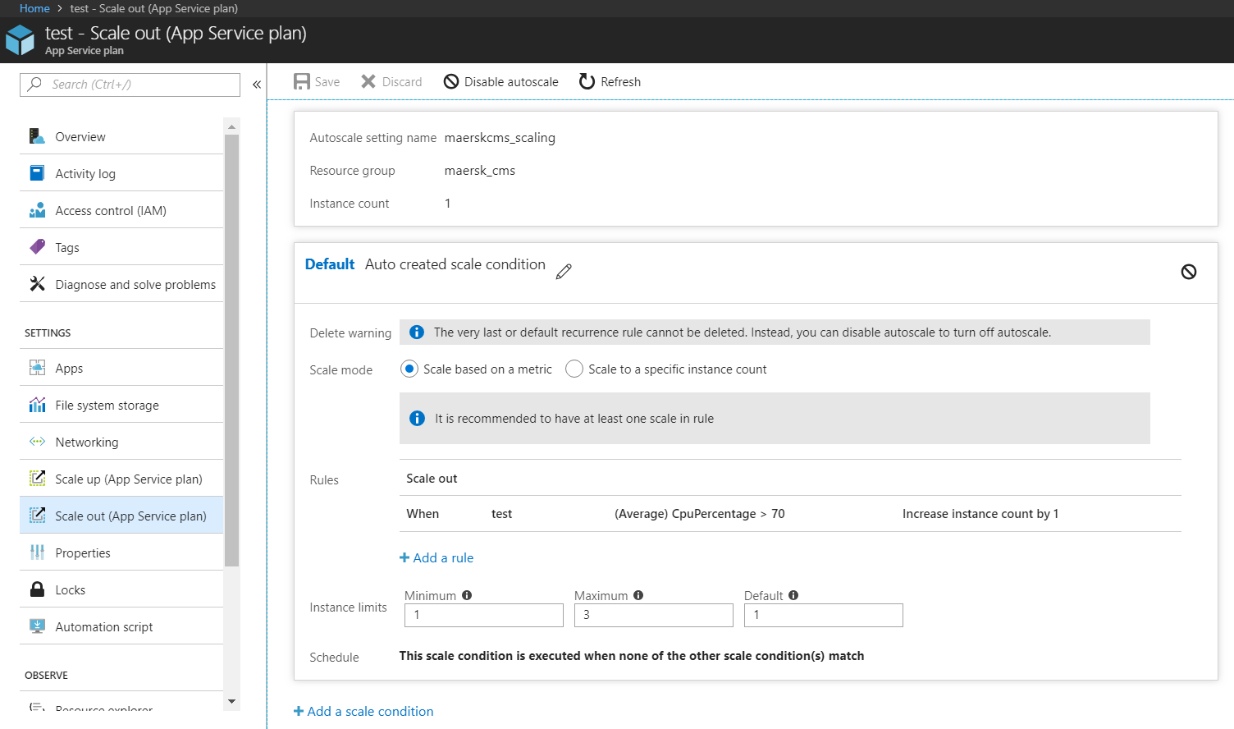

Figure 37. Scale out

## Investigate and Analyze Application

The Azure portal allows to analyze application using monitoring tools. The monitoring tools allows to view figures in a diagram by chosen metrics.

### CPU Usage

The diagram below shows the CPU time and Average Response Time of Maersk Line Container Management System. Since the Maersk CMS does not have users yet, therefore most of the time both of the metrics shows 0. However, there were several performance tests conducted, where the system simulated the user load of 3740 users and 7480 users within 5 minutes. The average response time of the application is 202.13 ms, which is around quarter second. Despite the fact that during the heavy user load the average response time is higher, overall the response time of the application is quite acceptable, as according to Maile Ohye, the Senior Principal Product Manager of Google, “2 seconds is a threshold for ecommerce website acceptability” (Anderson, 2018).

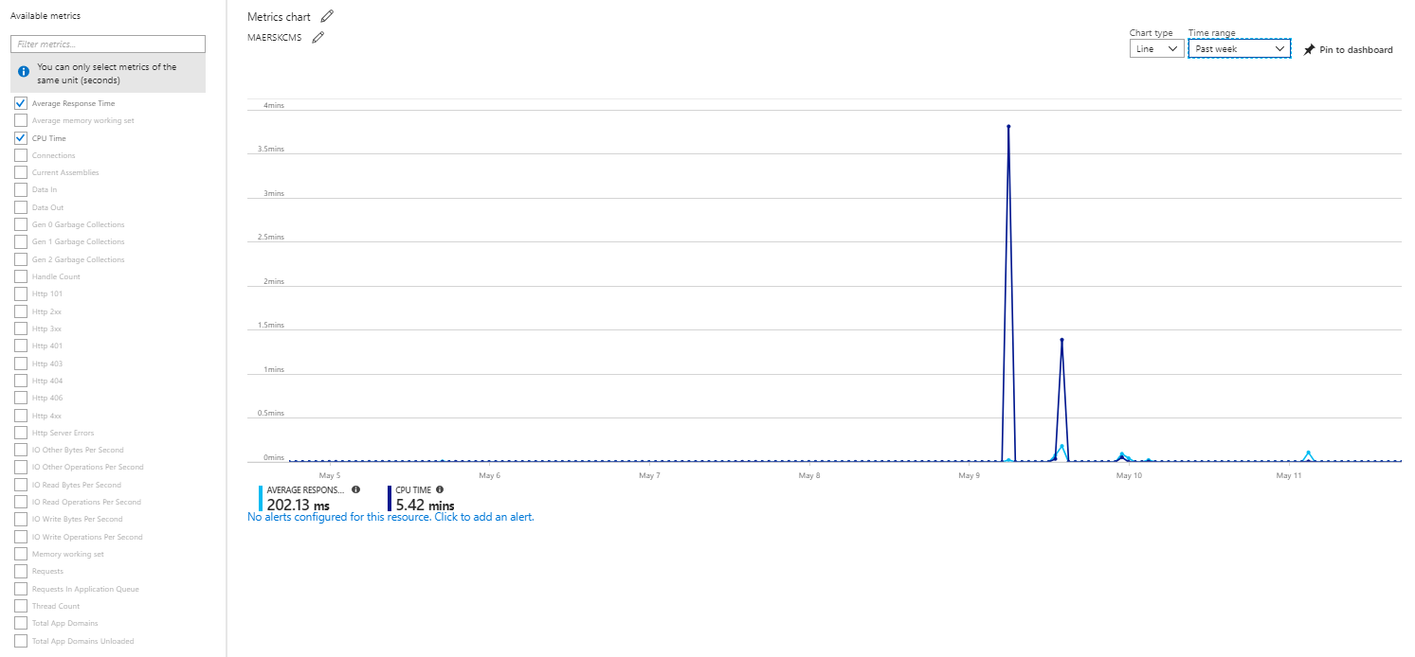

Figure 38. CPU Usage

### Data Metrics

The diagram below shows the data in and data out that as transmitted since the deployment of the application. The average memory working set is 18.77 Mb. While data in is 1.15GB in comparison with 6.62 GB of data out.

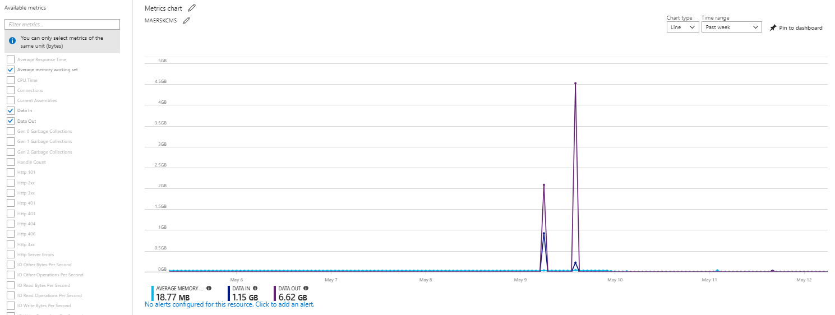

Figure 39. Data Metrics

### HTTP Requests

The diagram bellows displays the http requests metrics. As it is seen there were not any requests of HTTP protocols.

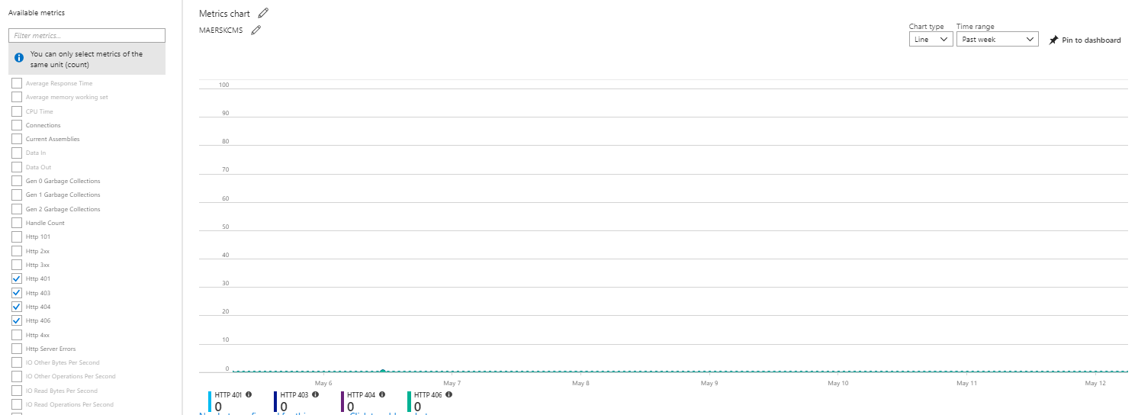

Figure 40. HTTP Requests

### Total requests

The diagram below shows 2 figures: the total number of requests and how much of the requests got errors.

Out of 1.1 Million requests that were made there are 0 errors were encountered by the system, which demonstrated high level of reliability.

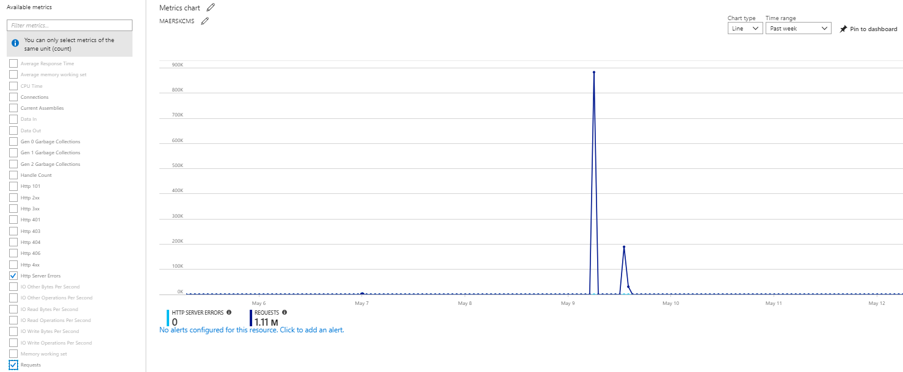

Figure 41. Total Requests

### Average Memory working set

The figure below sums up how much RAM was used by the application in average. The average memory working set is 18.77 Mb. Considering that the S2 tier is providing 3.5GB of RAM, the system has enough room for growth.

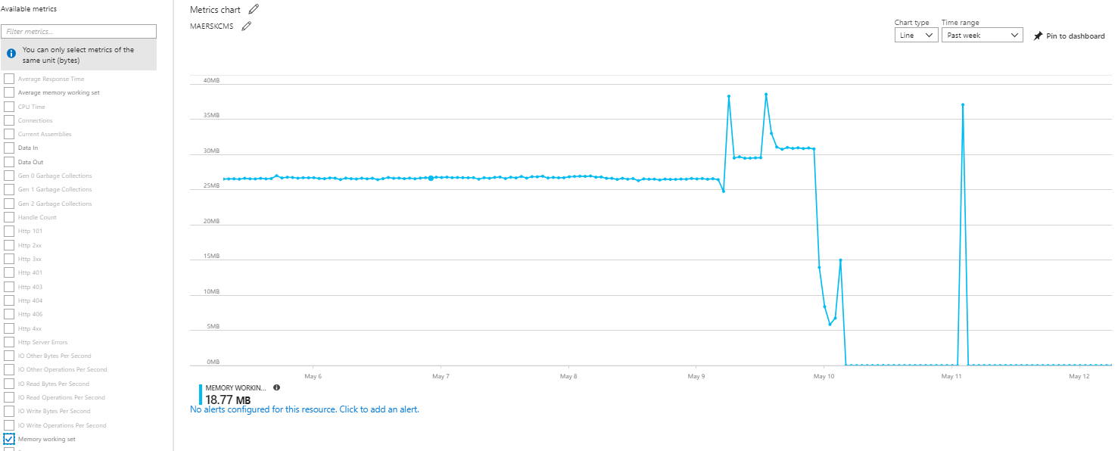

Figure 42. Average Memory Working Set

## Implementation and Discussions of Managed Databases (PaaS)

For the Maersk Line CMS, it was decided to implement The Azure SQL Database (PaaS) method of database deployment over creating a VM for SQL database due to the numerous benefits.

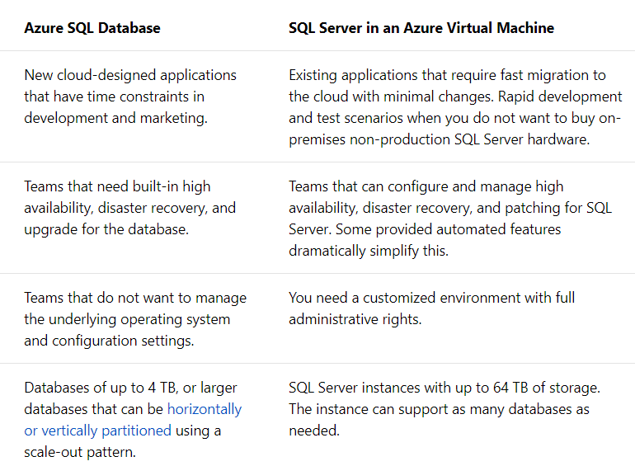

Figure 43. Comparison of Azure SQL Database and SQL Server on VM (docs.microsoft.com, 2018)

Firstly, using Azure SQL Database is more likely to save the cost than paying for Azure Server to run SQL on VM. The Azure SQL Database allows to use it for ‘free’, as it is included in the price of subscription to Azure SQL Database. The payment method for Azure SQL Database is pay-as-you-go, which means the company will only be charged for the amount of the memory that was used.

Secondly, the Azure SQL Database creates automatic back-ups (for 7 or more days depending on the tier), while in SQL on the VM the developer have to configure it manually.

Thirdly, there are built in security features by Azure that allows to protect the system against the unauthorized access.

Besides, safety, using the Azure SQL provides high speed of storing and retrieving data.

Additionally Azure SQL provides easy scaling up and scaling down options.

Eventually the Azure SQL allows to cut the efforts on managing the operation system and any configuration settings.

However running SQL on VM allows to have more control on database whereas in Azure SQL the developer may only use the provided features.

After the evaluation and comparison the developer have decided to choose Azure SQL Database.

In order to create the Azure SQL Database it is required to SQL Database section and click “New database” and fill up the details of the new database.



Figure 44. Creating New SQL Database

The developer needs to firstly configure its Firewall settings. This allows to register the IPs of devices the will be allowed to make changes to the database.



Figure 45. Firewall settings

Then the developer connects to the Azure database from SQL Server Management Studio.



Figure 46. Connection to server

Once the connection is established, the developer right clicks on database title, choosing “Tasks” and then “Deploy to Microsoft Azure SQL Database”.



Figure 47. Deployment of database

After the deployment the developer may use the performance monitoring toolы for database as well as to configure it.

## Screenshots of the Application

### Home page

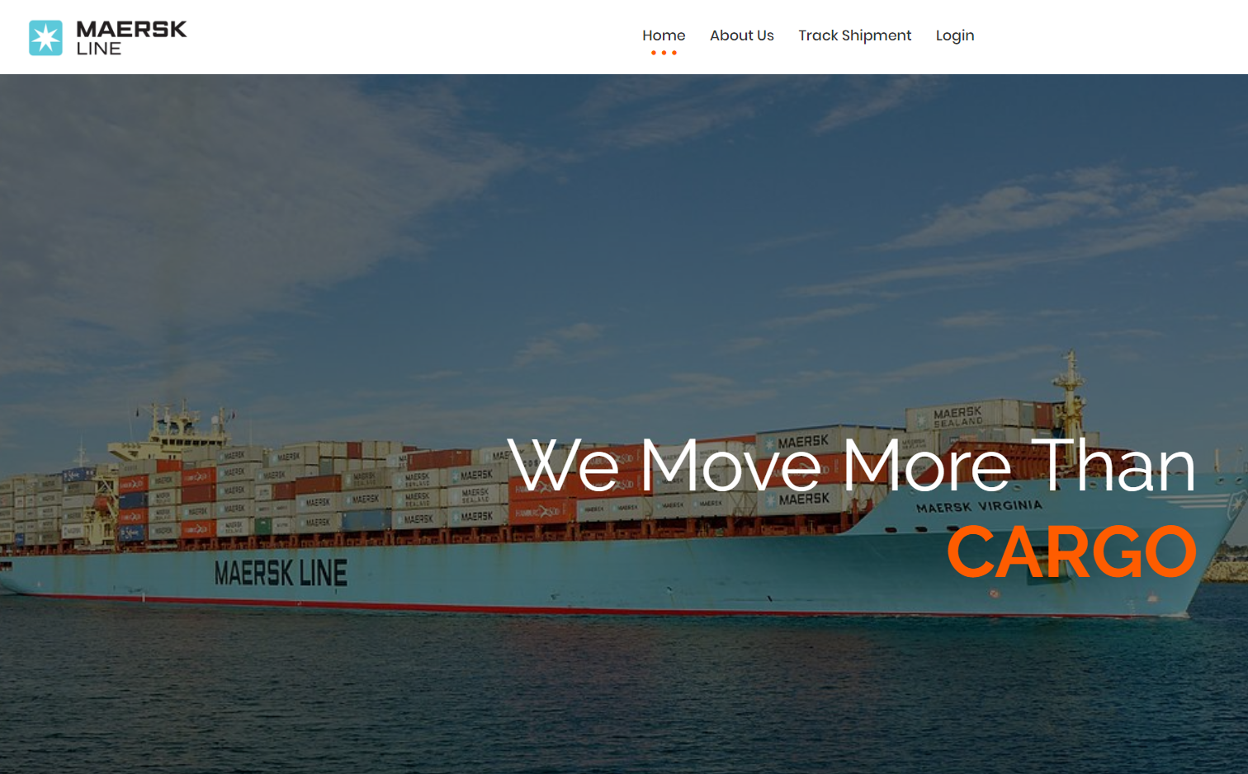

### About us page

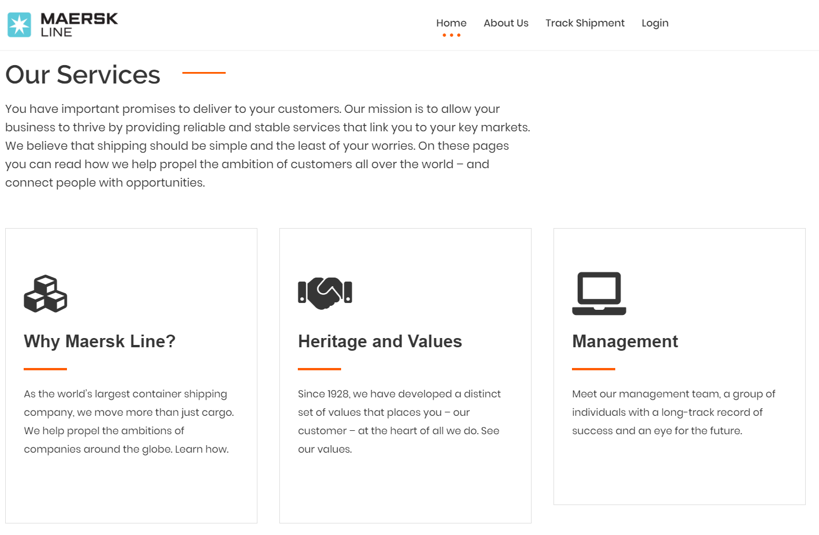

### External shipment tracking page (for customers, without login)

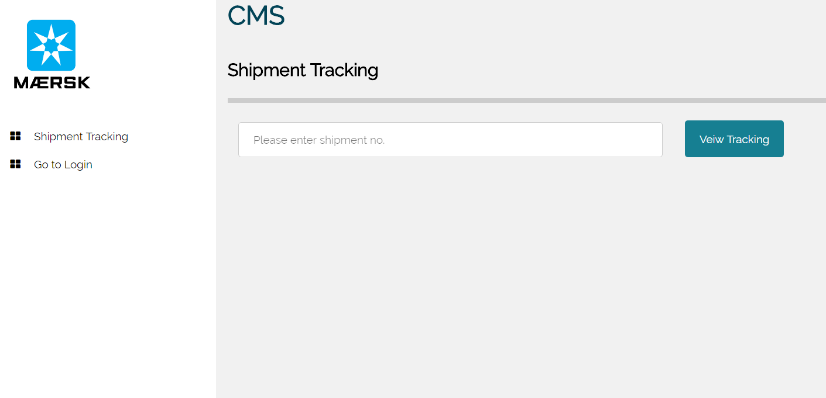

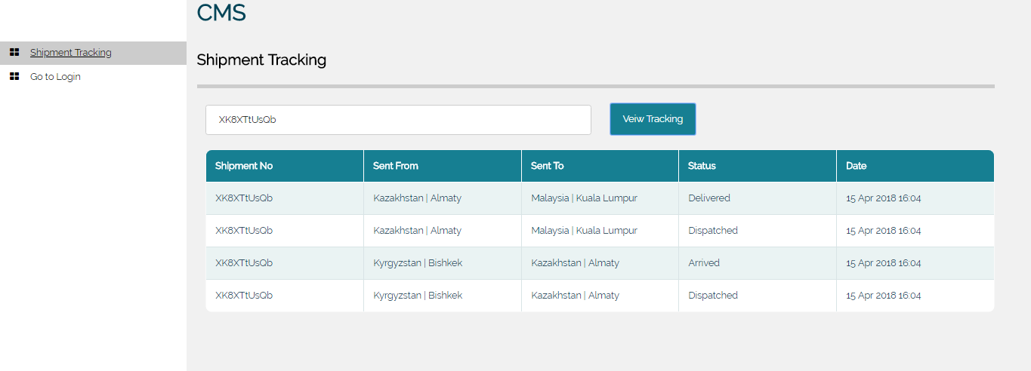

### Login page

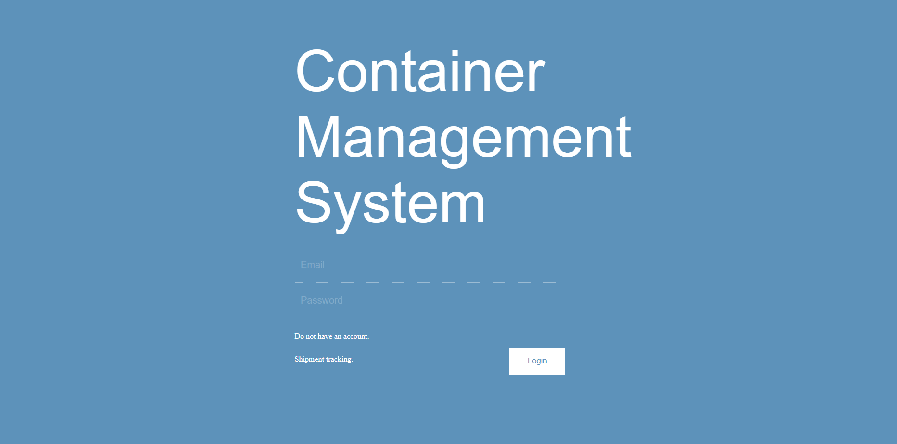

### Registration page

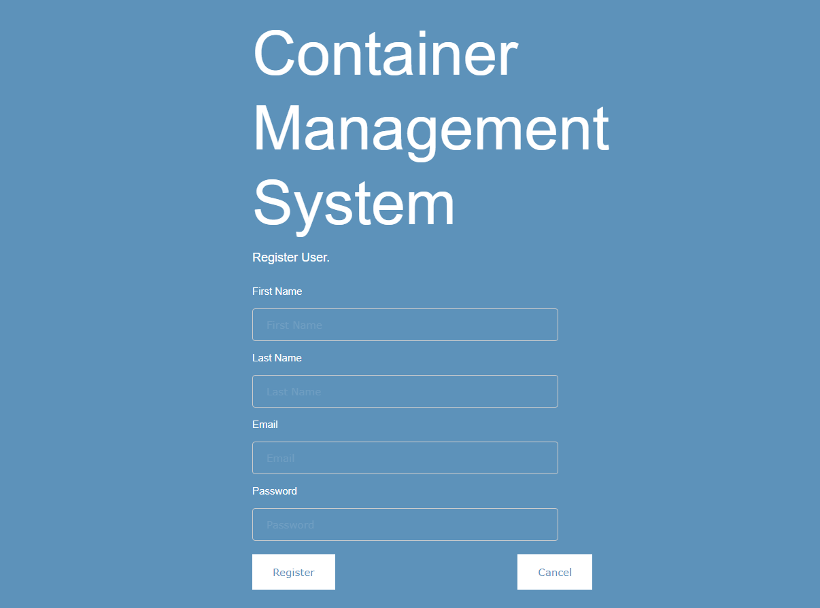

### Logged in as Admin: Profile page

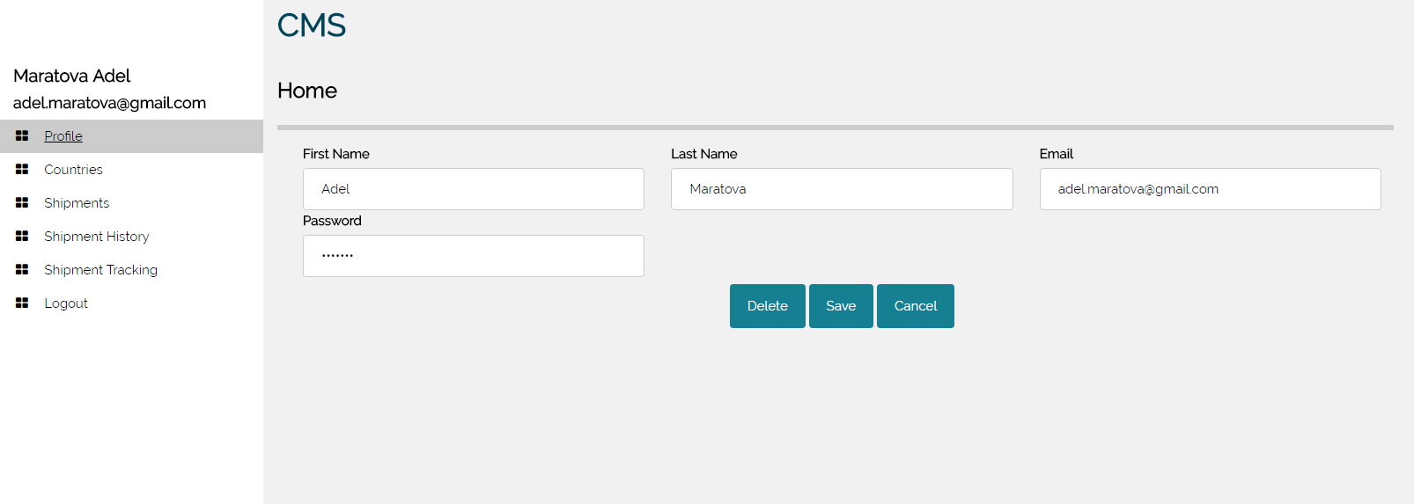

### Confirmation message about account deletion

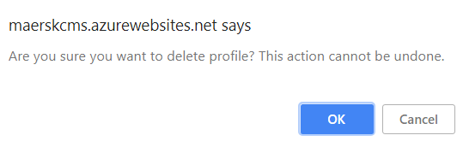

### Admin profile edited successfully

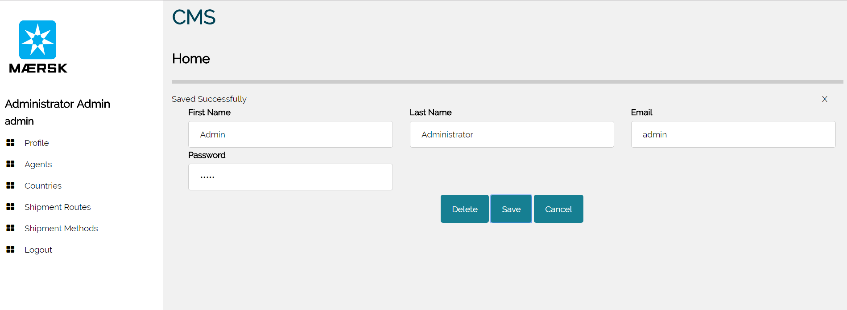

### Agents page

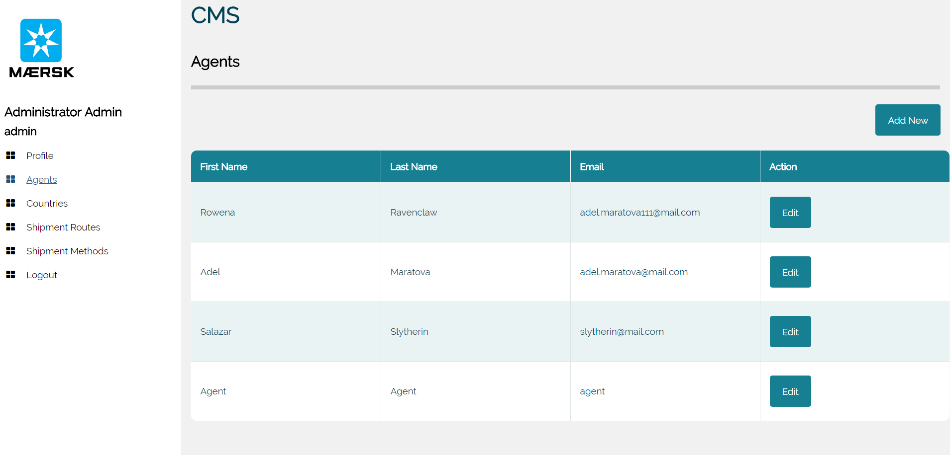

### Add new agent page

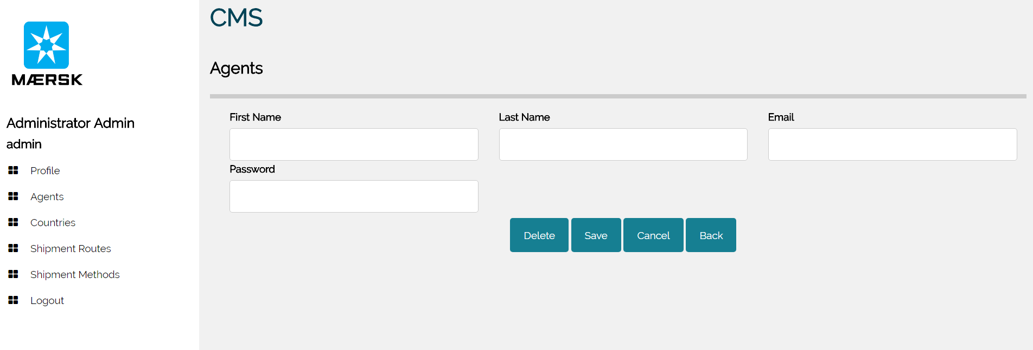

### Edit Agent info page

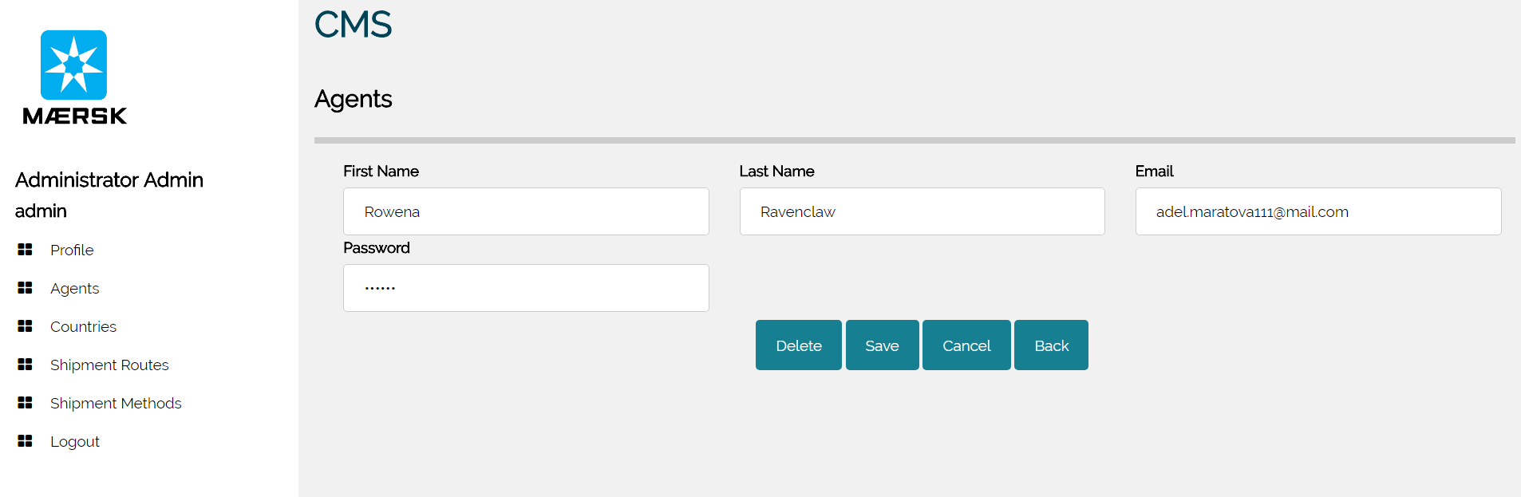

### Agent profile edited successfully

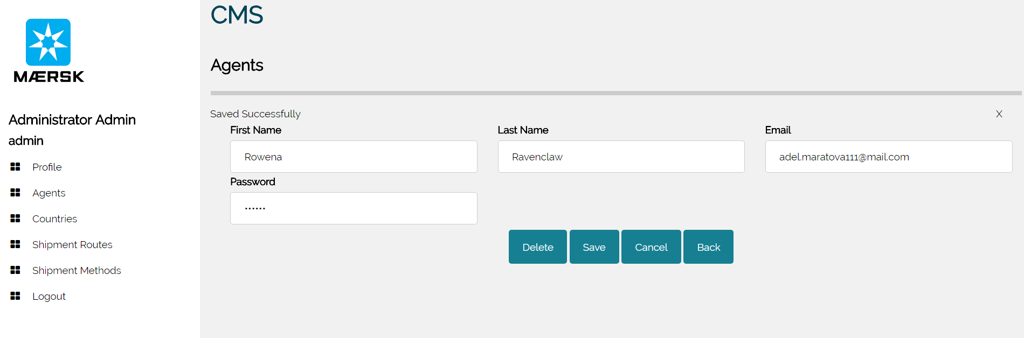

### Delete Agent profile

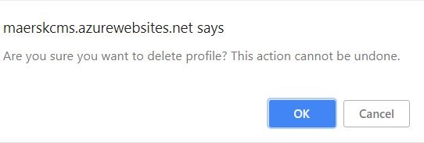

### Countries page

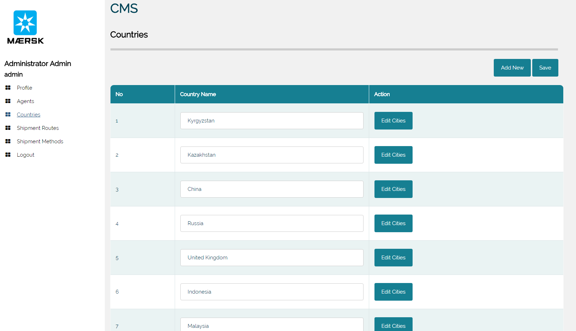

### Add new country

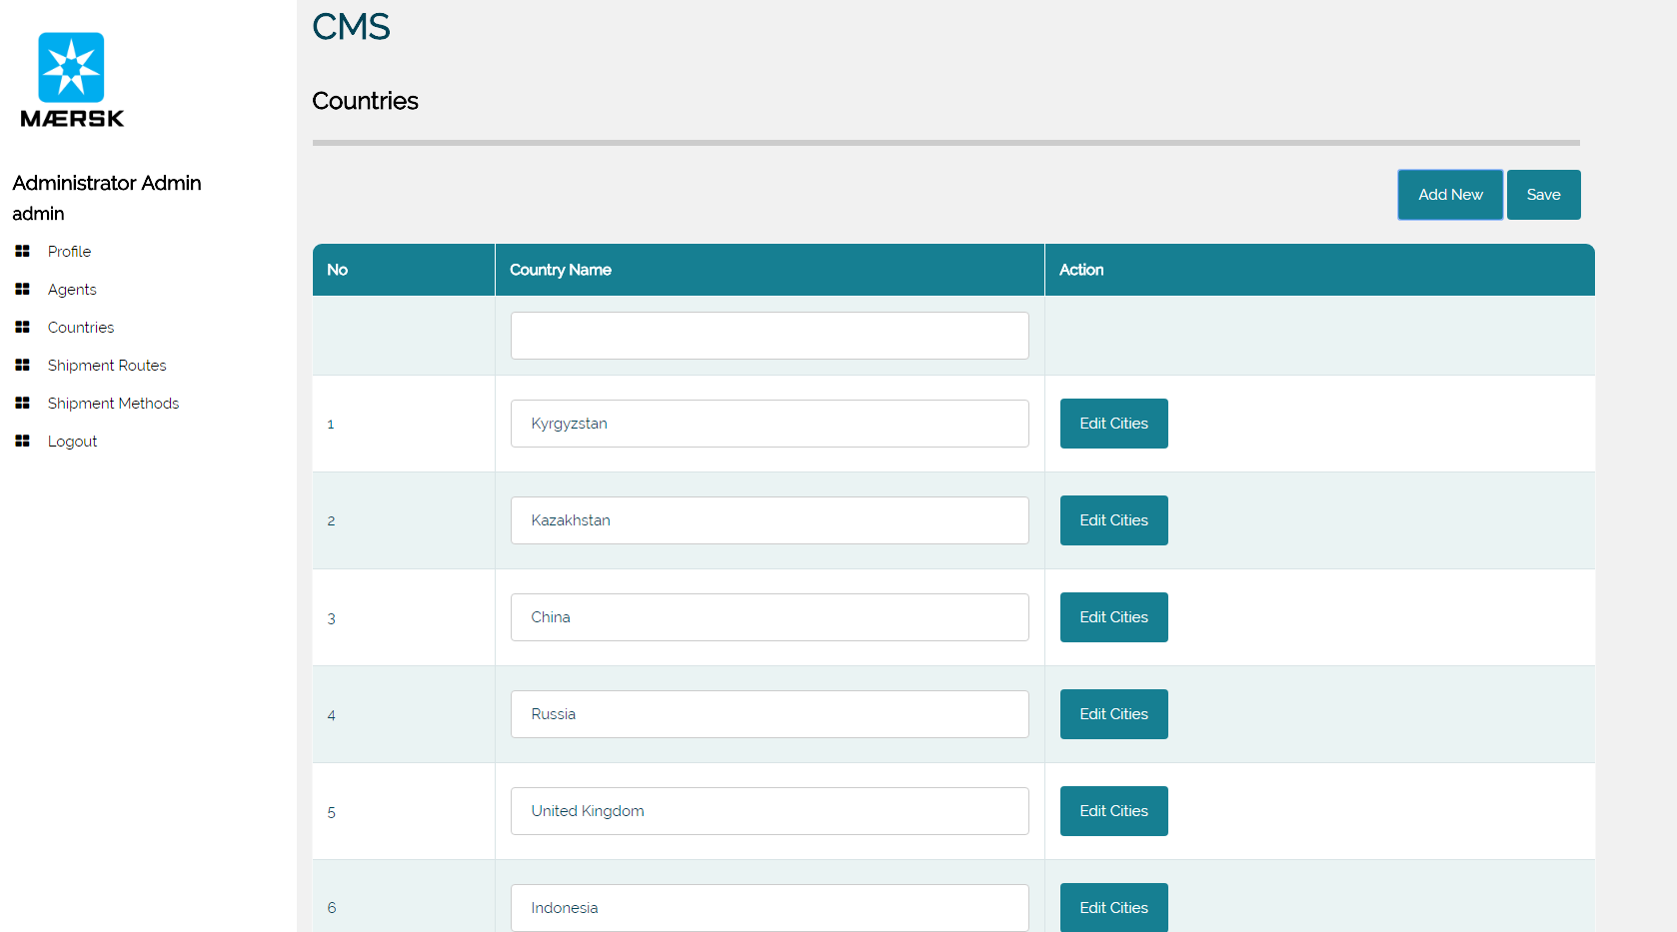

### Edit cities page

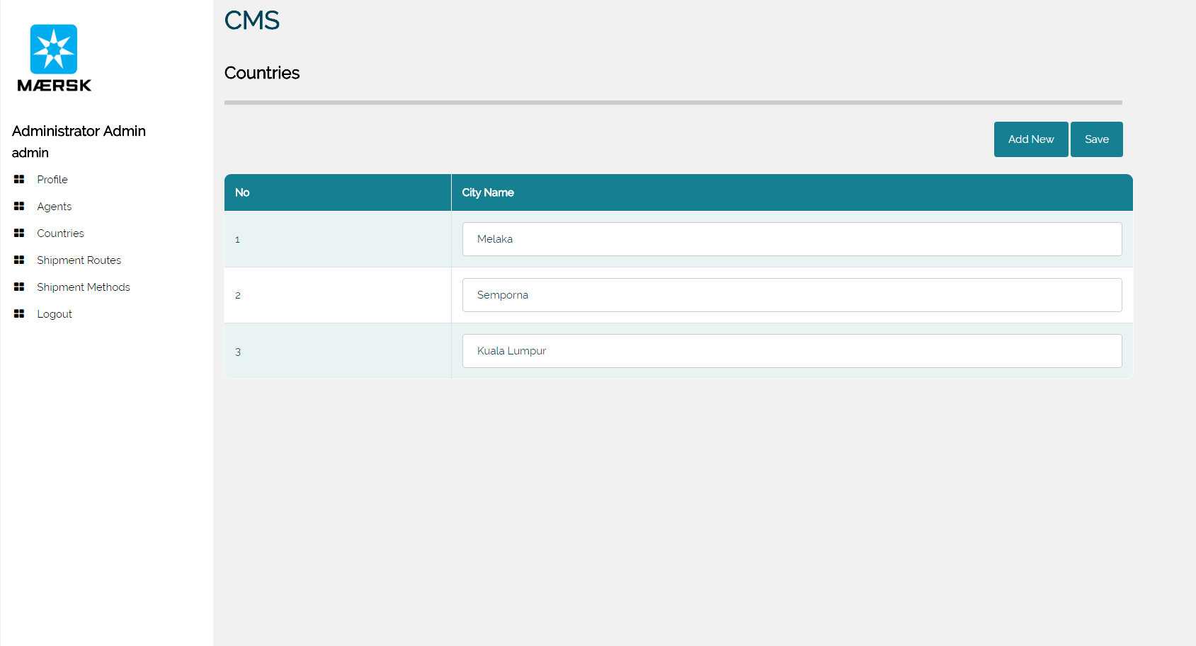

### Add new city (edit cities page)

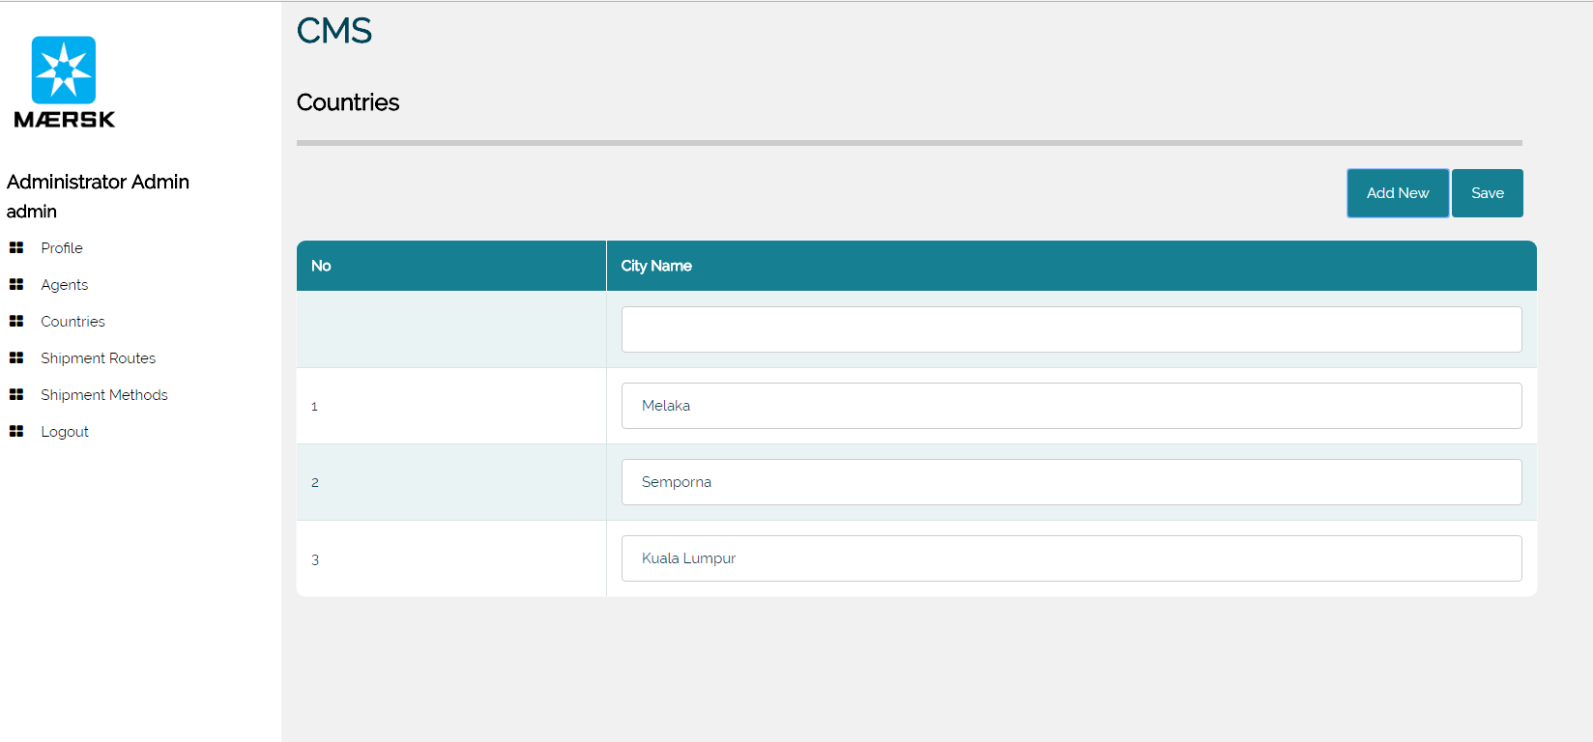

### Shipments page

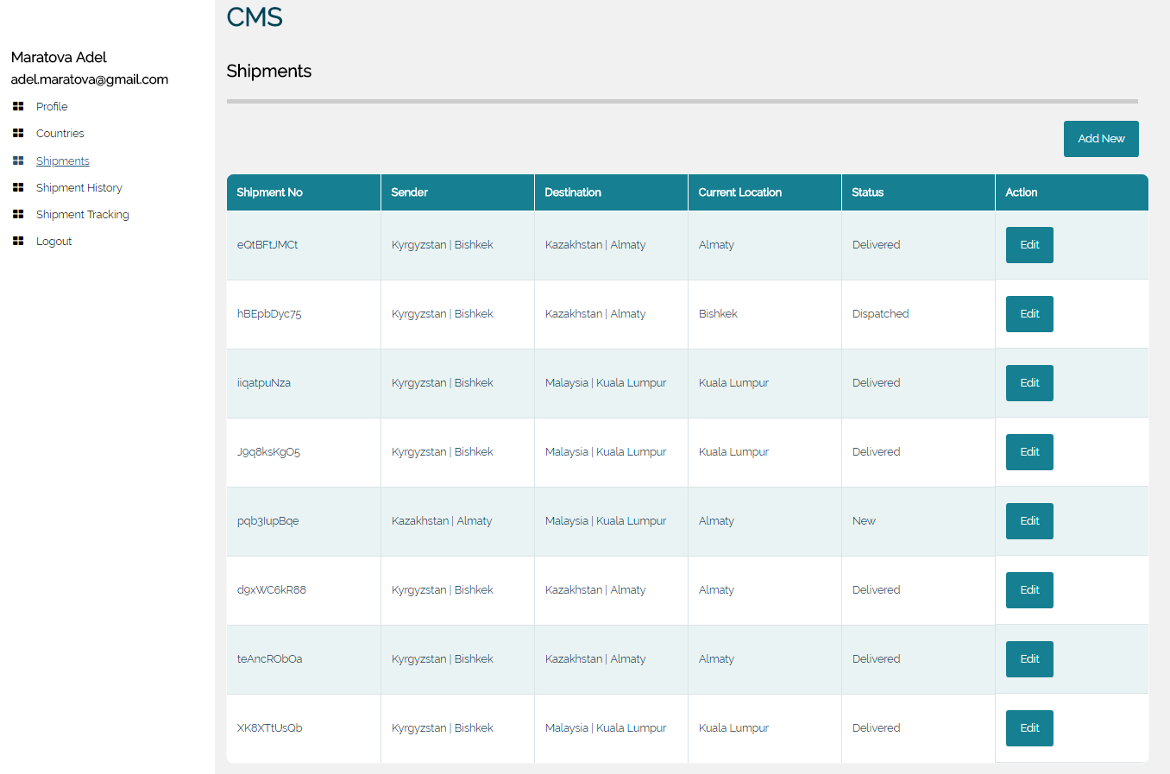

### Shipment methods page

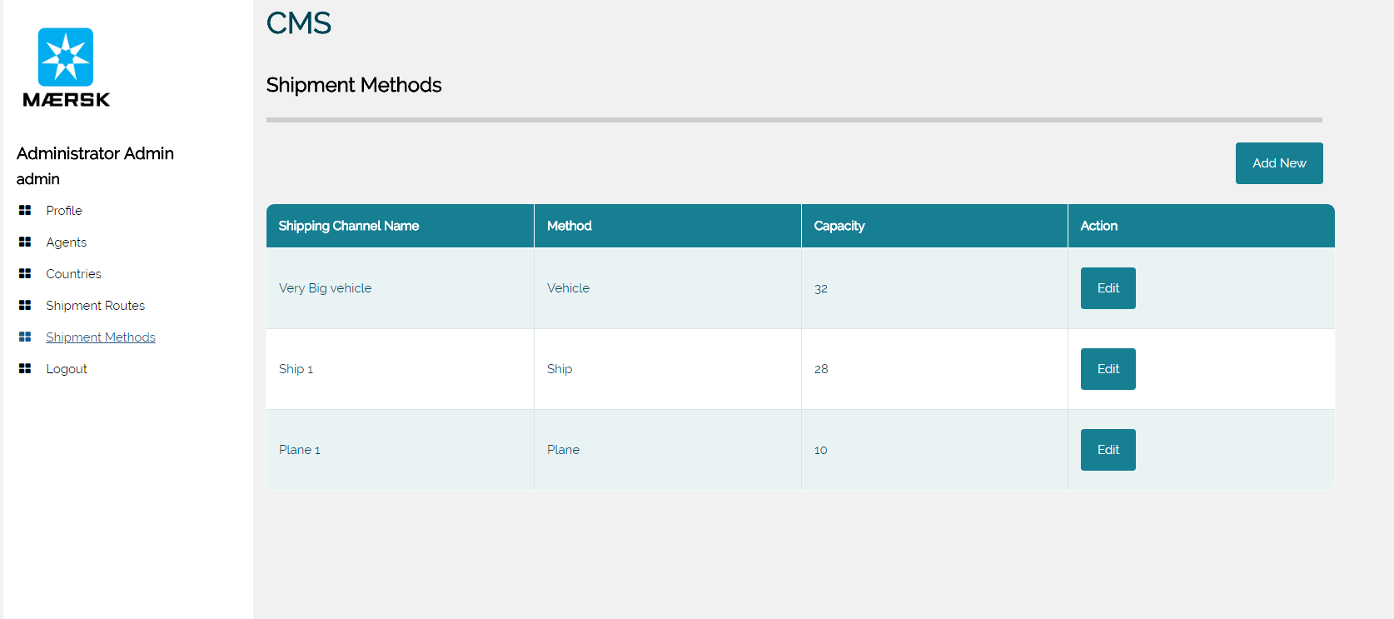

### Add new shipment page

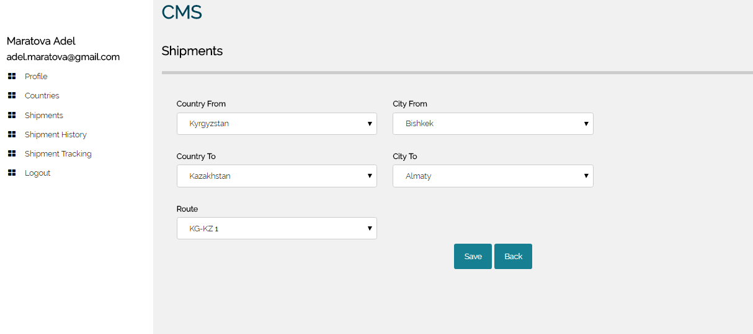

### Add New Shipment Method

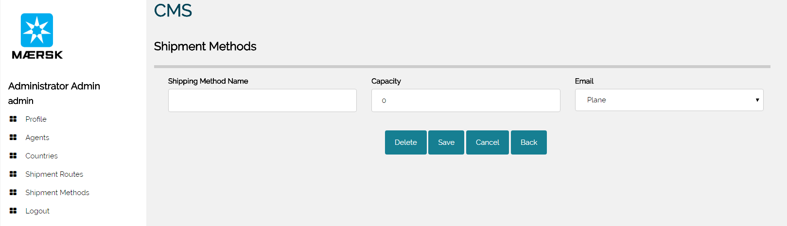

### Shipment Route Page

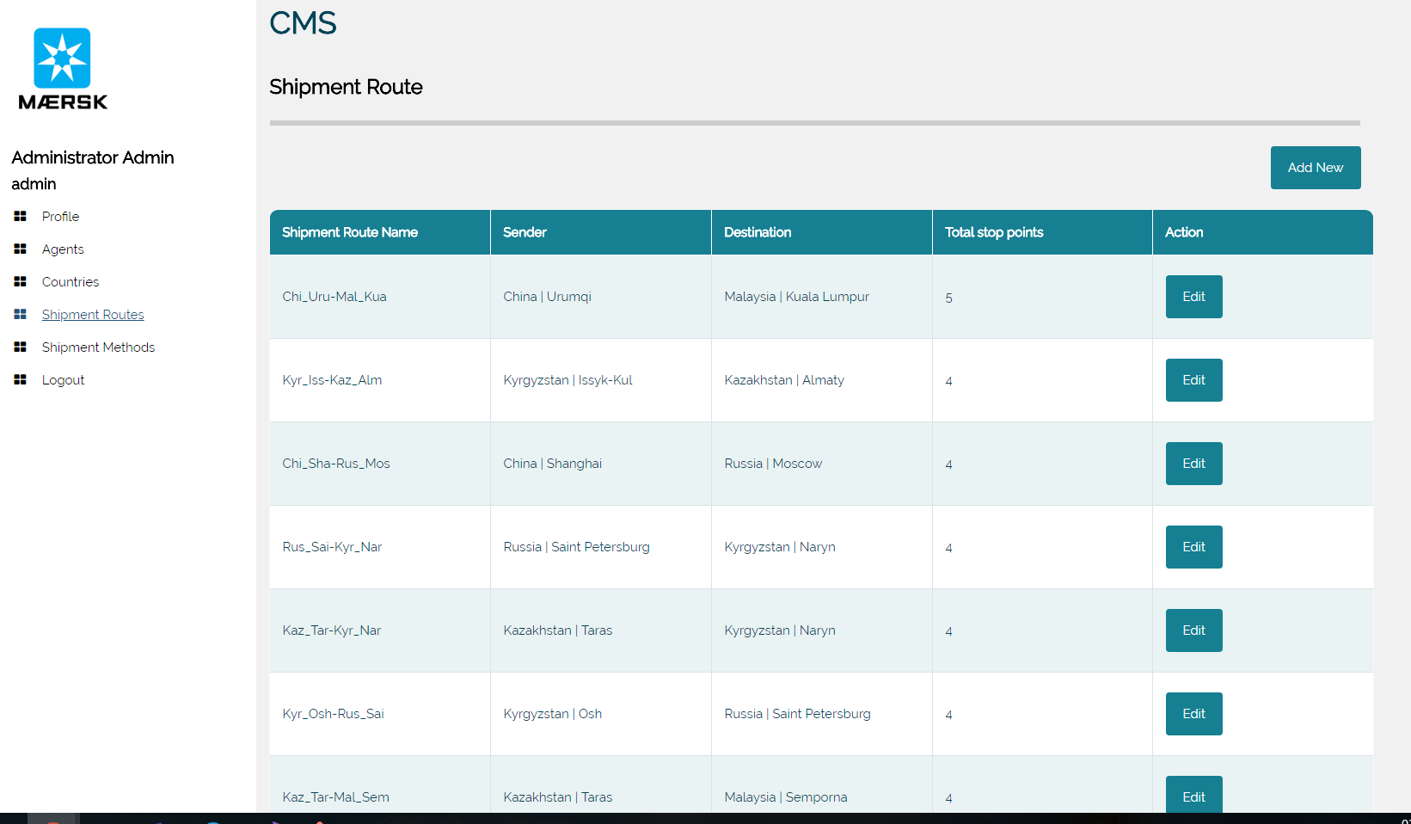

### Add New Shipment Route Page

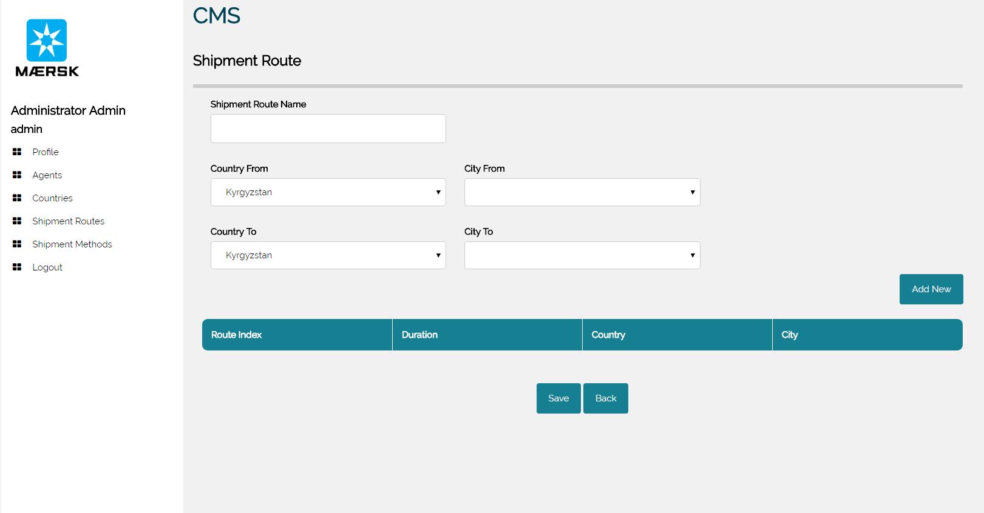

### Edit shipment route page

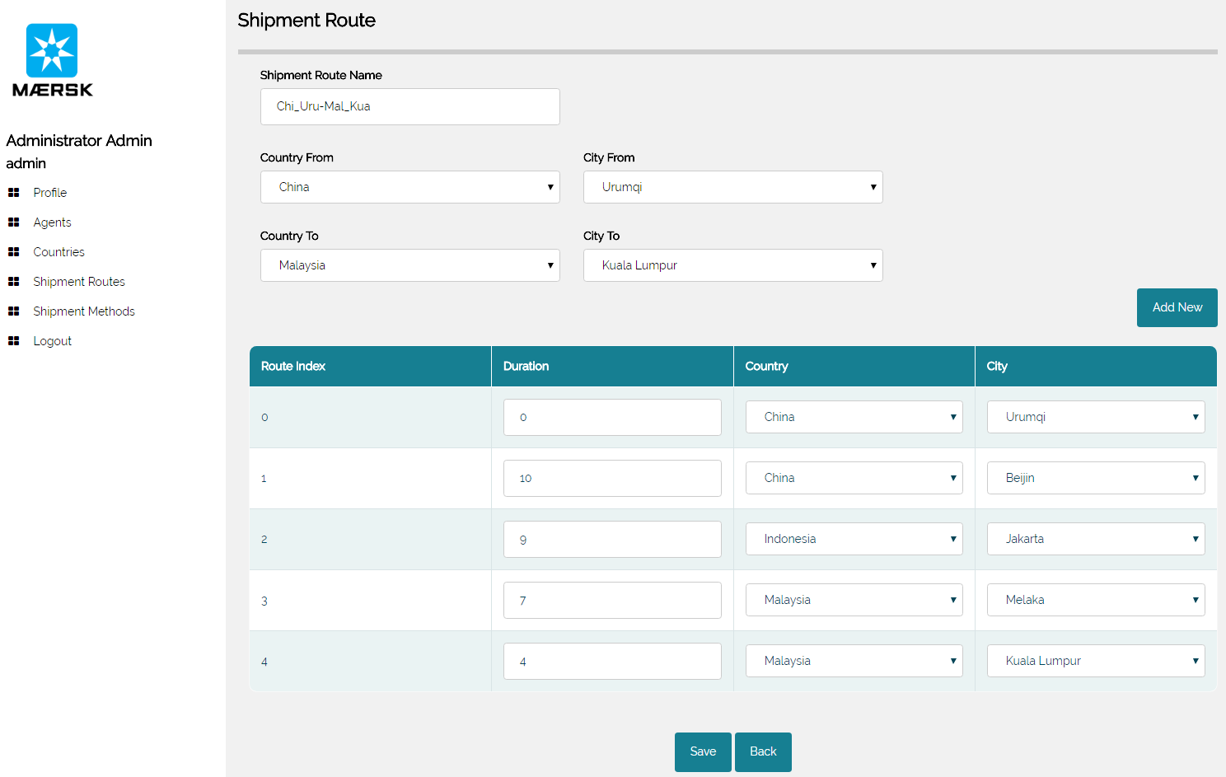

### Login as Agent: Profile page

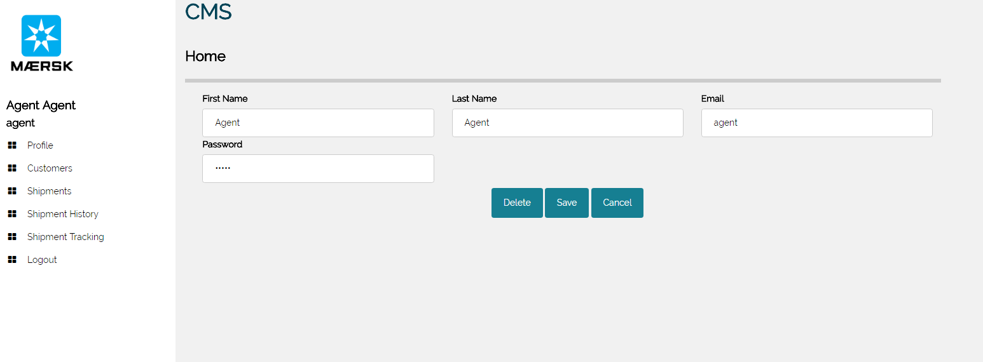

### Customers page

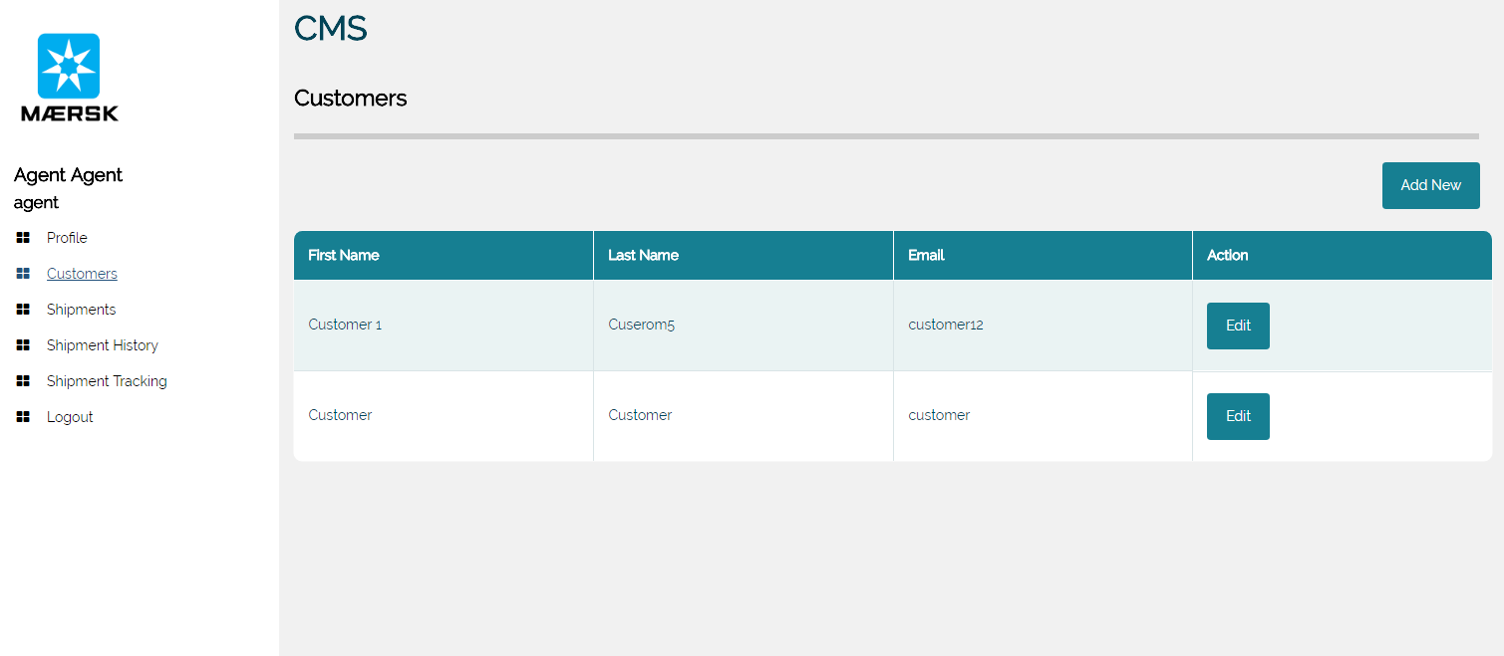

### Add New Customer Page

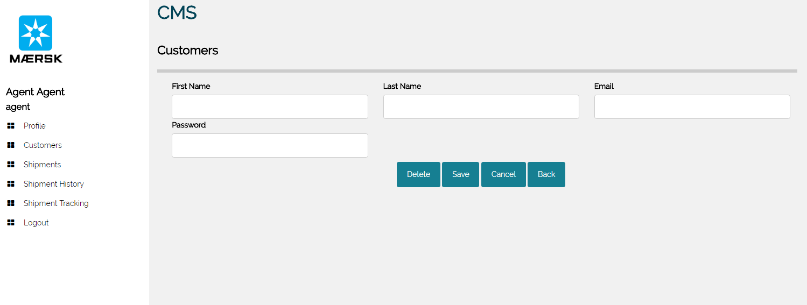

### Shipments page

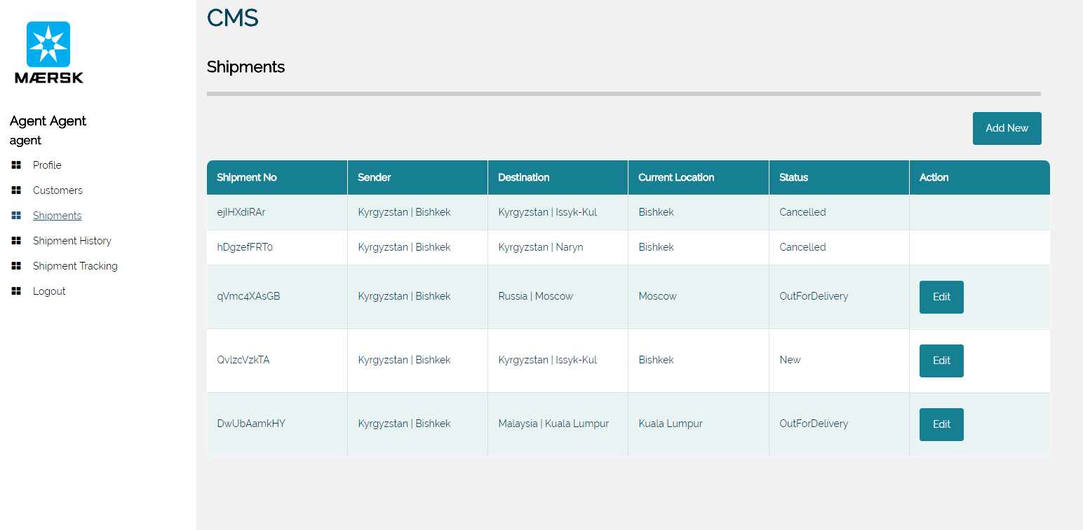

### Add New Shipment Page

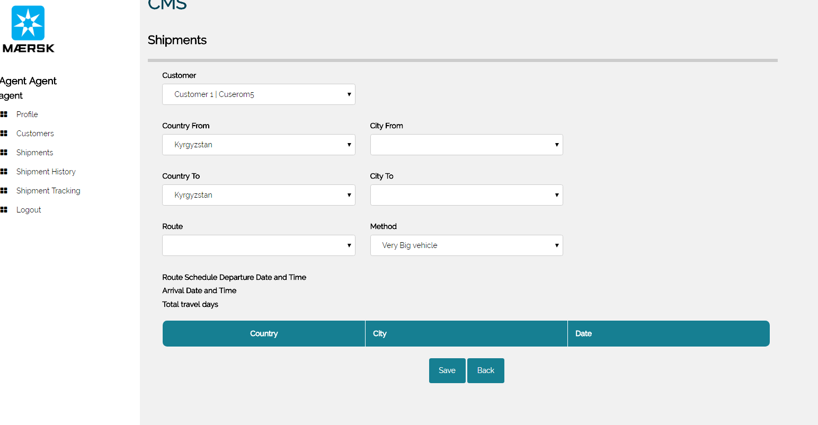

### Edit Shipment Page

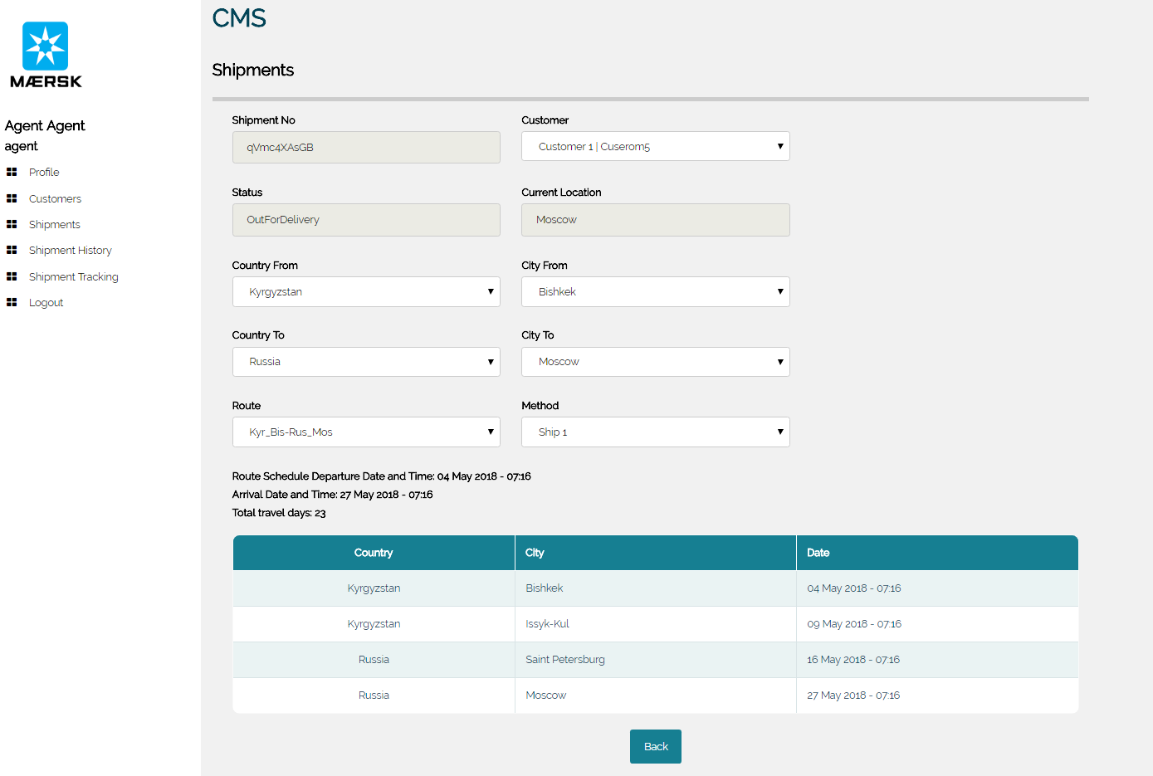

### Shipment History Page

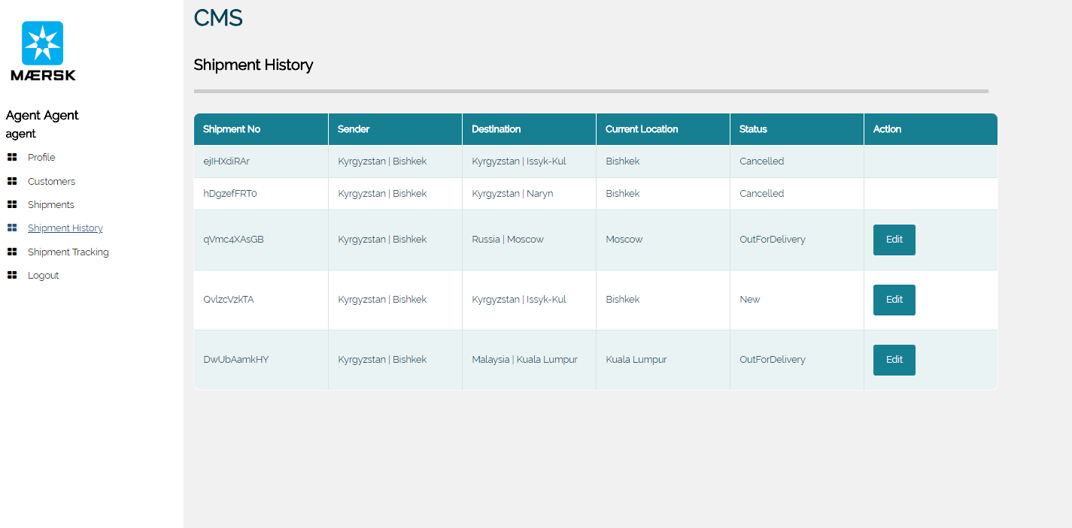

### Internal shipment tracking page

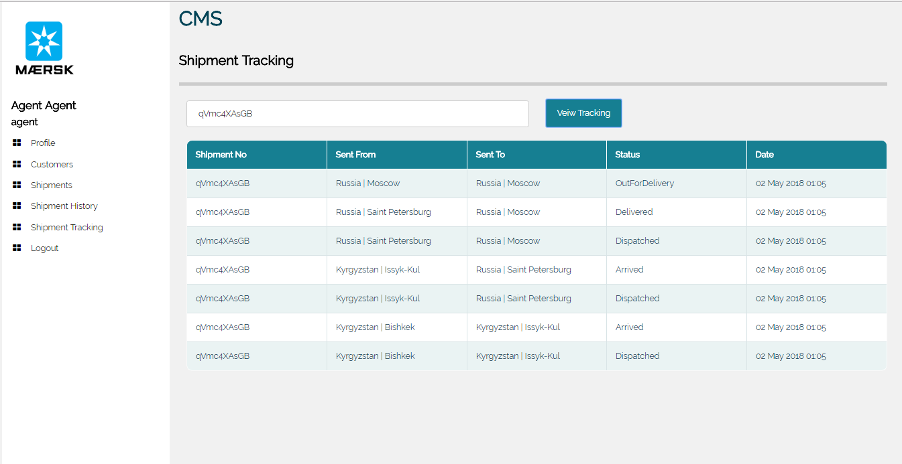

### Login as Customer

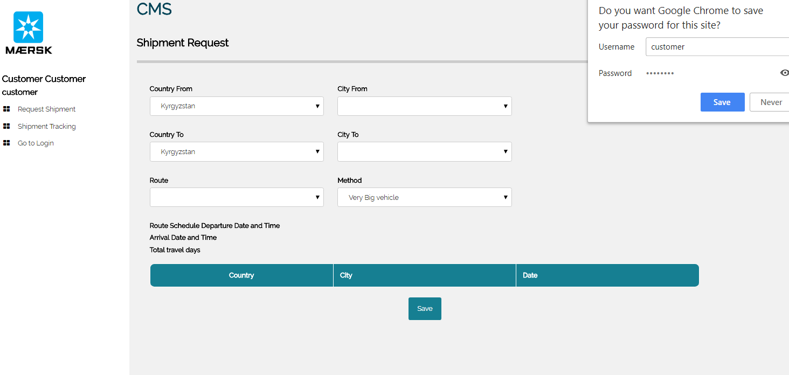

### Shipment Request Evaluation for Customer

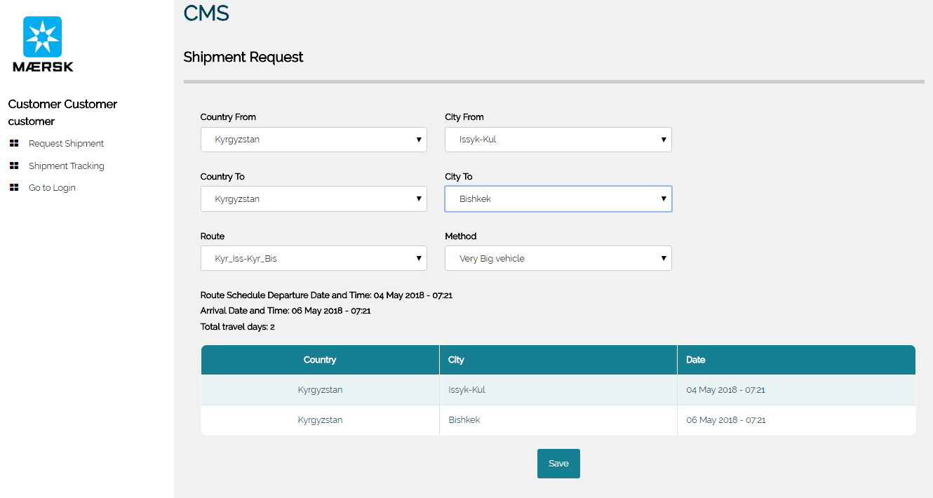

### Shipment request sent by customer

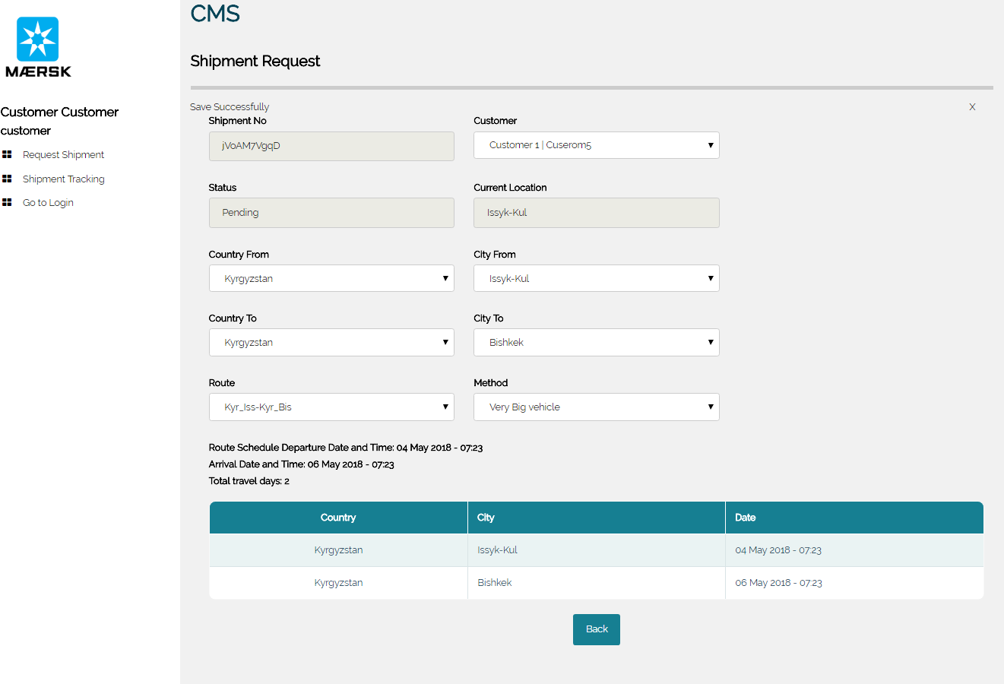

# Test Plan and Testing Discussion

## Test Plan

### Unit testing

|  |  |  |  |  |
| --- | --- | --- | --- | --- |
| **No.** | **Test Case** | **Description** | **Expected result** | **Result (+ Pass, - Fail)** |
| 1 | Login with correct credentials | User enters his/her username and password to sign in to the system | User signed in | + |
| 2 | Login with incorrect credentials | User enters wrong username and password to sign in to the system | The system pops-up the error message: “The username or password is incorrect” | + |
| 3 | Log out from the system | User press “Log out” button to sign out from the system | The system takes user back to login page | + |
| 4 | Add new agent | User fills up the ne agent data and clicks “Save” | The system should display “Saved successfully” message and create new agent record in the database | + |
| 5 | Edit agent profile | User tries to edit agent profile details and click “Save” | The system should display agent profile with updated data and “Saved successfully” message | + |
| 6 | Delete agent profile | User clicks “Delete” on the agent profile page | The system should pop – up message “Are you sure you want to delete profile? This cannot be undone.” | + |
| 7 | Add new country | User tries to add new country to the list of the shipping countries | The system should create new country title in the list of the countries | + |
| 8 | Edit country | User tries to edit country details and click “Save” | The system should display country profile with updated data and “Saved successfully” message | + |
| 9 | Delete country | User clicks “Delete” on the agent profile page | The system should pop – up message “Are you sure you want to delete profile? This cannot be undone.” | + |
| 10 | Add new route | User tries to create new route by filling up new route details and clicking “Save” | The system should display message “Saved successfully” and create new route record in the database | + |
| 11 | Edit route | User tries to edit route details and click “Save” | The system should display route details with updated data and “Saved successfully” message | + |
| 12 | Add new vessel | User tries to create new vessel by filling up vessel details and clicking “Save” | The system should display message “Saved successfully” and create new vessel record in the database | + |
| 13 | Edit vessel | User tries to edit vessel details and click “Save” | The system should display vessel details page with updated data and “Saved successfully” message | + |
| 14 | Delete vessel | User clicks “Delete” on the vessel details page | The system should pop – up message “Are you sure you want to delete profile? This cannot be undone.” | + |
| 15 | Add new customer | User fills up the new customer data and clicks “Save” | The system should display “Saved successfully” message and create new customer record in the database | + |
| 16 | Edit customer profile | User tries to edit customer profile details and click “Save” | The system should display customer profile with updated data and “Saved successfully” message | + |
| 17 | Delete customer profile | User clicks “Delete” on the customer profile page | The system should pop – up message “Are you sure you want to delete profile? This cannot be undone.” | + |
| 18 | Add new shipment | The user is trying to create new shipment choosing the sending country, destination country | The system creates new shipment record and automatically assigns the status | + |
| 19 | Update shipment status | The user is trying to change the shipment status by clicking the status button (value is depending on current shipment status) | The system should display shipment details page with updated data and the status button value should be changed next status) | + |
| 20 | Track shipment | The user is typing the shipment ID to view the tracking history of the shipment | The system should display the history pf tracking of the shipment by ID | + |
| 21 | Create shipping request | The user is filling up the shipment request details and clicks “Create” | The system should save the shipping request to the database and assign status “Pending” as well as display message “Saved successfully” | + |

## Performance Testing

Azure portal provides an option test the performance of the application by simulating requests from defined number of virtual users concurrently and providing the various metrics on the system performance during simulation.

In order to test the performance of Maersk Line Container Management System the developer decided to set the test where 250 virtual users will be sending the requests to the system within 5 minutes. The overview of the performance test results are shown below.

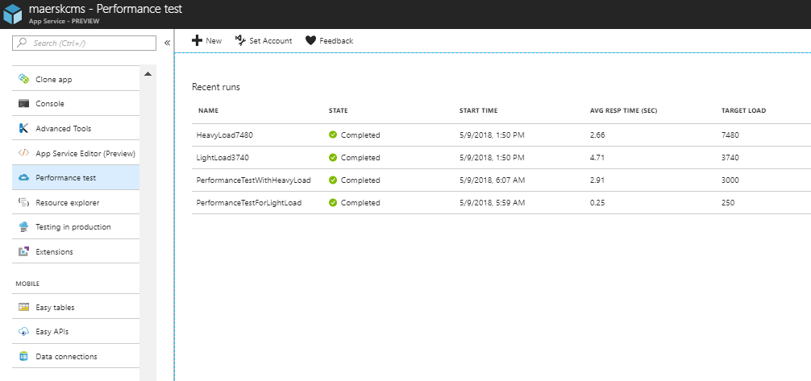

Figure 48. Performance test

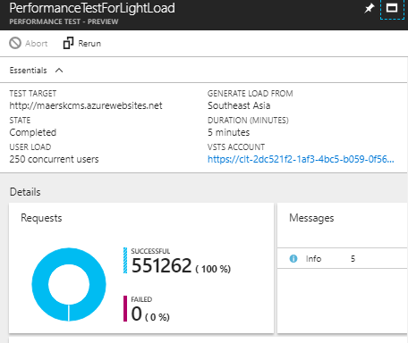

Figure 49. Performance test. Part 1

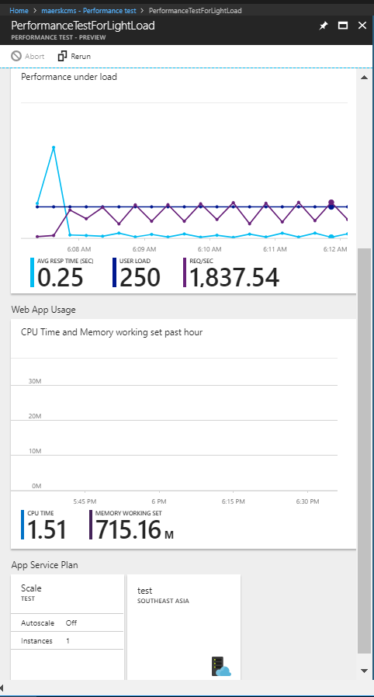

Figure 50. Performance test. Part 2

The average response time is 0.25 seconds, which is acceptable and pretty fast. The total number of the requests was 551,262 and none of them returned fail. Therefore it could be concluded that the application demonstrates good performance and the current tier suits well for serving 250 users concurrently within 5 minutes.

# Conclusion

At the end of this project the developer have designed, developed and published fully working Container Management System for Maersk Line which strictly follows the requirements that were defined. The system allows to manage entire process starting from creation of the request to the moment the shipment is getting dispatched from the destination point. Besides it allows to manage the assets and staff. The system was successfully tested and deployed and is totally ready for industrial use.

For the deployment, management and monitoring the Maersk Line CMS the Azure Cloud Platform was used. The Azure cloud platform allowed to meet most of the functional and non-functional requirements set by the client, such as Failover Management, scalability during peak seasons, increased availability, reliability, reduced cost of system maintenance, increased productivity and provisioning. Besides the Azure Cloud Platform allowed to measure the performance of the application, host the application on the cloud, analyze application metrics, scale up the project. The Azure Cloud platform has various tiers offering different features, and based on analysing the application data the best option was choosen.

# References

Barber, S. (2018). Acceptable application response times vs. industry standard. [online] SearchSoftwareQuality. Available at: https://searchsoftwarequality.techtarget.com/tip/Acceptable-application-response-times-vs-industry-standard [Accessed 15 Feb. 2018].

Docs.microsoft.com. (2018). Retry Pattern. [online] Available at: https://docs.microsoft.com/en-us/azure/architecture/patterns/retry [Accessed 5 Feb. 2018].

Docs.microsoft.com. (2018). Local Git Deployment to Azure App Service. [online] Available at: https://docs.microsoft.com/en-us/azure/app-service/app-service-deploy-local-git [Accessed 15 Feb. 2018].